IN-VIVO AND IN-SILICO STUDY ON THE EFFECTS OF ARYLIDENE HYDRAZINYL INDENOIMIDAZOLES ON Plasmodium berghei INFECTED RED BLOOD CELLS.

BY

OMONIJO BUKOLA ADEOLA
MATRIC NUMBER: 170026

BEING A PROJECT SUBMITTED TO THE DEPARTMENT OF MEDICAL LABORATORY SCIENCE, FACULTY OF BASIC MEDICAL SCIENCES, COLLEGE OF HEALTH SCIENCES, LADOKE AKINTOLA UNIVERSITY OF TECHNOLOGY, OGBOMOSO.

IN PARTIAL FULFILMENT OF THE REQUIREMENT FOR THE AWARD OF BACHELOR OF MEDICAL LABORATORY SCIENCE (B.MLS) DEGREE.
SEPTEMBER, 2023

CERTIFICATION

I hereby certify that this project work was carried out by OMONIJO BUKOLA ADEOLA with matric no: 170026 of the department of Medical Laboratory Science, Faculty of Basic Medical Sciences, Ladoke Akintola University of Technology, Ogbomosho, Oyo State, Nigeria.

PROJECT SUPERVISOR DATE
PROF LEO EHIGIE

HEAD OF DEPARTMENT DATE
PROF CHRIS IGBENEGHU

EXTERNAL EXAMINER DATE

DEDICATION
This project is dedicated to the Almighty God, the giver of life, for his mercies over my life throughout the course of my academic journey and this research study.

ACKNOWLEDGEMENT
All thanks to God Almighty, the king of glory for his love and divine grace in my life all through my academic journey.

My gratitude goes to my supervisor, Prof. L.O Ehigie for his support, encouragement, and patience during the course of this project work. I also appreciate the major help received from Mr. Fiyinfoluwa Ojeniyi who took his time to guide me through the course of this project.

To the Head of the Department of Medical Laboratory science, Prof. Chris Igbeneghu and other members of staff of the department, I say thanks to you all.

My sincere appreciation goes to my parents, who have sacrificed their resources towards my academics and continually encouraging me to be better. Also, to my siblings, Olamide and Subomi, for always been there to encourage and support me.

TABLE OF CONTENT

CERTIFICATION ii
DEDICATION iii
ACKNOWLEDGEMENT iv
TABLE OF CONTENT v
LIST OF FIGURES viii
LIST OF TABLES x
ABSTRACT xi
CHAPTER ONE 1
INTRODUCTION 1
1.1 Background of Study 1
1.2 Aims and Objectives 3
CHAPTER TWO 4
LITERATURE REVIEW 4
2.1 Malaria and its impact globally 4
2.2 Current treatment options available and the need for new antimalarial compounds. 6
2.3 Impact of existing antimalarial medications on infected red blood cells 10
2.4 Plasmodium Berghei 11
2.5 The use of Mice as an Infection model system 12
2.6 Life Cycle of Plasmodium Bergehi 13
2.7 Arylidene Compound 14
2.8 Gene Expression Analysis 15
2.9 Molecular Docking 19
2.10 In-vivo studies on Plasmodium infected mice 21
CHAPTER THREE 23
MATERIALS AND METHOD 23
3.1 Synthesis of ARYLIDENE HYDRAZINYL INDENOIMIDAZOLES (AHI) 23
3.2 Pharmacological studies 25
3.3 In-vivo Studies 25
3.4 In-Silico studies 28
CHAPTER FOUR 32
RESULT 32
4.1 In-vivo Studies 32
4.2 Insilco Studies 44
CHAPTER FIVE 54
DISCUSSION AND CONCLUSION 54
5.1 DISCUSSION 54
5.2 CONCLUSION 56
REFERENCES 58
APPENDICES 65
APPENDIX I: ADMET STUDY RESULTS 65

LIST OF FIGURES
Figure 3.1: (E)-3a,8a-dihydroxy-3-((3-hydroxybenzylidene)amino)-2-thioxo-1,3,3a,8a-tetrahydroindeno[1,2d]imidazol-8(2H)-one 24
Figure 4.1: Blood smear of Plasmodium bergehi infected cells of mice after first day of infection 33
Figure 4.2: Representative photomicrograph of blood smear of infected mice stained with Giemsa stain 33
Figure 4.3: Percentage parasitemia level in mice infected Plasmodium bergehi 35
Figure 4.4: Percentage chemo-suppression of Plasmodium berghei in mice treated with test compound at different doses 37
Figure 4.5: The graph represents the percent parasitaemia and percent chemo-suppression in mice infected with malaria parasites and treated with different drugs 39
Figure 4.6: PCA (principal component analysis) Plot of analysed dataset identifying clusters of samples similar to each other 45
Figure 4.7: Dispersion Plot of the dataset used to measure the variability in gene expression levels, with those highly dispersed plotted towards the top and those with low dispersion towards the bottom 45
Figure 4.8: Heat Map showing different expression levels of genes in the data set, with genes in the red region highly expressed and those in the blue region expressed at a low level 46
Figure 4.9: Volcano Plot highlighting significantly differentially expressed genes and fold change distance with up-regulated genes scattered upwards in red dots and down-regulated genes scattered downwards with green genes 47
Figure 4.10: 2D Structure representing interactions between (E)-3-((2,4-dihydroxybenzylidene)amino)-3a,8a-dihydroxyl-2-thioxo-1,3,3a,8a-tetrahydroindeno[1,2-d]imidazol-8(2H)-one and FANCJ-like Helicase 49 Figure 4.11: 2D Structure representing interactions between Chloroquine (control) and FANCJ-like Helicase 51

LIST OF TABLES
Table 3.1: Packages/Libraries utilized for gene expression analysis 39
Table 4.1: Chemo-suppression Data 41
Table 4.2: Animal Survival Rate 43
Table 4.3: Suppressive Activity of AHI and survival time of P. berghei infected mice in the 4-day suppressive test. 43
Table 4.4: Table showing the binding affinities and interacting amino acids of compounds (test and control) versus the target protein (FANCJ-like Helicase) 52

ABSTRACT
Malaria remains a significant global health burden, necessitating the development of novel antimalarial agents. Arylidene hydrazinyl indenoimidazoles (AHIs) have shown promising antimalarial activity in-vitro, however, their effects on Plasmodium berghei-infected red blood cells (RBCs) and their potential in-vivo efficacy have not been extensively investigated. In the in-vivo arm of the study, Plasmodium berghei-infected mice were treated with a synthesised AHI compound, and the parasitaemia levels and survival rates in the host were monitored. This study performed the analysis of gene expression dataset GSE198587 available on the Gene expression Omnibus (GEO). Using molecular docking with the software iGEMDOCK, the binding modes and affinity of the test compound within the active site of the selected Plasmodium protein (FANCJ-like Helicase) was explored to gain insights into the interactions between the AHI test compound and molecular targets within Plasmodium-infected RBCs. ADMET Studies were also carried out on the test compound. The results demonstrated a significant reduction in parasitaemia levels and an increase in the survival rates of mice treated with the test compound compared to the control group especially for the mice group treated with 25mg/kg. Results from the molecular docking also revealed that the compound exhibited strong interactions with the key protein ‘FANCJ-like Helicase’ involved in replication of the parasite's genome, DNA, nucleotide and ATP binding and also in the development of the parasite's blood stages. These findings suggest the potential of this AHI test compound as effective antimalarial agents both in-vivo and in-silico. The combination of in-vivo and in-silico approaches in this study provides comprehensive insights into the effects of AHIs on Plasmodium berghei-infected RBCs.

CHAPTER ONE

INTRODUCTION

1.1 Background of Study
Malaria is prevalent in about 100 countries, affecting 2400 million people, nearly half of whom live in Africa south of the Sahara. More than 90% of malaria deaths occur in Africa, particularly among children under the age of five. Plasmodium, a parasite that infects humans through the bite of infected Anopheles mosquitos, is the cause of malaria. symptoms of malaria can include fever, chills, headache, muscle pains, and weariness(Snow & Omumbo, 2006). Malaria has substantial economic and social consequences in addition to causing significant morbidity and mortality. More than a century of global effort and research directed at improving malaria prevention, diagnosis, and management has resulted in a lower disease and death burden (Talapko et al., 2019). Antimalarial medicines are currently the principal therapeutic choices for malaria. The World Health Organization (WHO) advises multiple medication classes for the treatment of malaria, depending on the type of Plasmodium causing the illness and the clinical status of the patient (Lara & Tariq, 2022).
Despite these treatment possibilities, drug resistance is a major issue in malaria treatment. The incidence of Plasmodium falciparum parasites resistant to artemisinin derivatives, the primary component of the WHO-recommended first-line treatment for P. falciparum malaria, has increased in recent years (Leann et al., 2016). As a result, novel antimalarial drugs that are effective against drug-resistant forms of the parasite, have a favourable safety profile, and are affordable and accessible to people living in malaria-endemic areas are urgently needed. Because of its ability to target specific enzymes in the parasite that causes malaria, arylidenes have been investigated as potential anti-malarial medicines. The malaria parasite relies on a number of metabolic processes not seen in human cells, making them prospective therapeutic targets (Cobbold et al., 2021). Arylidenes have been demonstrated to limit the action of these enzymes, suggesting that they could be turned into useful anti-malarial medicines. More study is needed, however, to completely understand their mechanism of action and to maximize their efficacy and safety for human use.
While these compounds have shown promising results in laboratory studies, they are still in the early stages of research, and it is unknown whether they will be effective or safe in humans. More research is needed to fully comprehend their potential as anti-malaria drugs and their potential risk profile (Sá et al., 2011).
Malaria and its causal agent, Plasmodium, are important to study because of the considerable illness and mortality they cause around the world. The discovery of novel antimalarial medications is of particular significance in this regard.
The goal of this research is to gain a better understanding of the molecular mechanisms underlying the antimalarial action of Arylidene hydrazinyl indenoimidazoles, which could lead to the creation of more effective and selective malaria treatments. This study will use in-vivo studies and molecular docking to investigate the interactions between the selected test compound and a key protein in infected red blood cells at an atomic level. This will provide a detailed understanding of the structural alterations that occur in infected cells following chemical treatment.
In summary, the purpose of this study is to use in-vivo and in-silico studies to investigate the effects of Arylidene hydrazinyl indenoimidazoles on Plasmodium-infected red blood cells in order to better understand their antimalarial mechanisms and prospective effect on the mice, which will aid in the development of more effective drugs for the treatment of malaria.

1.2 Aims and Objectives
Whilst arylidene hydrazinyl indenoimidazoles have been found as promising chemicals for malaria treatment, the molecular processes by which they operate on Plasmodium-infected red blood cells remain unknown. As a result, the primary goal of this study is to use in-vivo ad in-silico studies to evaluate the effects of Arylidene hydrazinyl indenoimidazoles on plasmodium-infected red blood cells, so as to;
- To better understand the methods through which certain drug molecules interact with infected cells and parasites.
- To find possible drug candidates that have the potential to be effective in the treatment of malaria.
- To assess the drug compounds' potential toxicity to human red blood cells.
- To evaluate the binding affinity and specificity of Arylidene hydrazinyl indenoimidazoles for plasmodium-infected red blood cells.
- To provide insight on the mechanism of action of Arylidene hydrazinyl indenoimidazoles on plasmodium-infected red blood cells, with the goal of informing the development of new and more effective antimalarial medicines.

CHAPTER TWO

LITERATURE REVIEW

2.1 Malaria and its impact globally
Malaria is a disease with a long history that dates back to antiquity. It was recorded in writings as early as 2700 BC in both Egyptian and Chinese literature, with symptoms including lethal recurrent fevers and splenomegaly. The disease had reached Rome by 200 BC, and by the eleventh century, it had spread throughout Europe. It made its way to England in the fifteenth century. Plasmodium, a parasite that infects humans through the bite of infected Anopheles mosquitos, is the causative agent of malaria. Malaria symptoms include fever, chills, headache, muscle aches, and fatigue (Snow & Omumbo, 2006). When the infection is severe, it can cause anaemia, kidney failure, and cerebral malaria (a type of malaria that affects the brain). Malaria is a critical public health issue in Sub-Saharan Africa, where the majority of cases and fatalities occur. It is estimated that about 200 million cases of malaria occur each year, with over 400,000 deaths (Prevention, 2021).
Malaria infections and deaths have been decreasing significantly in recent years as a result of greater efforts to battle the disease (Shretta et al., 2017). The World Health Organization (WHO) started the Roll Back Malaria (RBM) initiative in 2000, with the goal of halving malaria fatalities by 2010 and reducing them by 75% by 2015. The RBM collaboration and other efforts have resulted in tremendous progress in lowering malaria burden, but much more work remains to be done to achieve global elimination of the disease. This reduction in the disease's impact is the result of enormous efforts and research over the last century focused at improving malaria prevention, diagnosis, and management worldwide (Plewes et al., 2019).
Malaria has substantial economic and social consequences in addition to causing significant morbidity and mortality. The disease can cause absence from work and school, which can reduce economic production and educational attainment. Malaria can also raise healthcare expenses for individuals and governments alike, as well as contribute to poverty and food insecurity (World Malaria Report 2020). Malaria has a substantial worldwide health and development impact. Some of the key impacts include:
Mortality: Malaria is the major cause of death in many underdeveloped nations, especially in Sub-Saharan Africa. Malaria claimed the lives of 409,000 people globally in 2019, the majority of them were children under the age of five.
Morbidity: Malaria can cause a variety of symptoms such as fever, chills, headache, lethargy, muscle pain, and anaemia. These symptoms can lead to diminished productivity and a lower quality of life. Economic impact: Malaria has the potential to have a considerable impact on economic development and poverty alleviation efforts. The condition has the potential to diminish productivity, raise healthcare costs, and reduce investment in impacted areas. Disproportionate impact on vulnerable populations: Malaria disproportionately affects vulnerable populations such as pregnant women, children, and the poor. Pregnant women are more vulnerable to severe malaria, which can result in maternal anaemia, poor birth weight, and even death. Impact on education: Malaria is a major cause of school absenteeism, particularly among youngsters in Sub-Saharan Africa. This has the potential to harm education and future economic possibilities. Effect on health-care systems: Malaria poses a huge strain on health-care systems, especially in developing nations. This can result in a shortage of resources for addressing other health conditions and a lack of access to healthcare for many people (Halliday et al., 2020). Malaria is being combated by the WHO and other organizations through a combination of methods such as insecticide-treated bed nets, indoor residual spraying, and antimalarial medication. Furthermore, research is ongoing to create new techniques to restrict the spread of malaria, such as vaccinations and genetically modified mosquitos (Marshall & Taylor, 2009).

2.2 Current treatment options available and the need for new antimalarial compounds.
There are several treatment options available for malaria, which include:
    - Antimalarial drugs:
Antimalarial medicines are the most often used malaria treatment. These medications are used to eliminate the parasites that cause the sickness. They constitute the mainstay of malaria treatment and have helped to reduce the disease's global impact (Staines & Krishna, 2012). Artemisinin-based combination treatments (ACTs), which are currently recommended by the World Health Organization (WHO) as the first-line treatment for uncomplicated malaria, are examples of common antimalarial medications. ACTs are medication combinations that contain artemisinin in one of the medicines. Artemisinin is a highly effective antimalarial medication that decreases parasite load in the blood quickly (Maiga et al., 2021). Chloroquine and sulfadoxine-pyrimethamine (SP) are older medications that are still used in locations where malaria is resistant to ACTs (Roux et al., 2021). Monotherapies based on artemisinin: Artemisinin-based monotherapies are single medications that contain the most effective antimalarial treatment, artemisinin. However, because using artemisinin alone can result in medication resistance, WHO does not advocate it. In non-immune travellers, doxycycline, azithromycin, and atovaquone-proguanil are also utilized as an alternate treatment (Tan et al., 2011).
The appropriate choice of antimalarial drug depends on the species of the parasite causing the infection, the severity of the disease, and the patient's general health status, as well as the resistance patterns of the parasite in the area where the patient was infected. Resistance to antimalarial drugs is a major concern, and WHO closely monitors the emergence of resistance and updates its treatment guidelines accordingly. Adherence to the full course of the appropriate antimalarial drug is important to ensure the parasite is fully eliminated and to prevent the development of resistance (White, 2004).
In some cases, patients may require a second-line treatment, usually with another antimalarial drug or a combination of drugs, in case of resistance or for severe cases of malaria. Antimalarial drugs may have side effects, which vary depending on the drug and the patient. These side effects should be closely monitored by healthcare professionals and appropriate measures taken if necessary.
    - Quinine:
Quinine is an older antimalarial drug that is still used in some areas, particularly for treating severe malaria. Quinine is used to treat severe malaria caused by Plasmodium faciparum, particularly when the patient is unable to take other antimalarial drugs. Quinine is given intravenously or intramuscularly, and the treatment course typically lasts for 7-10 days (Achan et al., 2011). Quinine is associated with a number of side effects, such as cinchonism (tinnitus, headache, nausea, and confusion), thrombocytopenia, and hypoglycaemia. These side effects need to be closely monitored by healthcare professionals, and appropriate measures taken if necessary. Quinine is not recommended for the treatment of uncomplicated malaria, as it is less effective than ACTs and other antimalarials. Resistance to quinine has been reported in some areas, which further limits its utility as a treatment option (Achan et al., 2009). WHO recommends that quinine should only be used in specific situations when other options are not available, and it should be used in combination with other antimalarial drugs. In some cases, the use of quinine may be considered as a second-line treatment option if the patient is unable to take other antimalarial drugs or if the strain of malaria is resistant to other drugs.
    - Other medications used to prevent and treat malaria:
Primaquine is an 8-aminoquinoline drug that is used to clear the liver stage of the parasite, which is important to prevent relapses in vivax malaria. Primaquine is usually given in combination with other antimalarials such as chloroquine or ACTs (Ashley et al., 2014). Another medication is Atovaquone-proguanil which is a combination drug that is used to prevent and treat malaria in non-immune travellers. It is taken daily, starting one or two days before travel, and continuing for seven days after leaving the malaria-endemic area (Osei‐Akoto et al., 2005). We also have Doxycycline a tetracycline antibiotic that is used as an alternative antimalarial prophylaxis for non-immune travellers (Tan et al., 2011). Azithromycin is a macrolide antibiotic that is used as an alternative antimalarial prophylaxis for non-immune travellers. Proguanil is a synthetic biguanide that is used as a prophylactic agent against malaria, usually in combination with chloroquine or atovaquone-proguanil.
It's important to note that these drugs have a different mechanism of action, indication and side effects, and the choice of drugs will depend on the patient's general health status, the resistance patterns of the parasite in the area where the patient was infected, and the severity of the disease. Also, consulting a healthcare professional and following their recommendations is crucial when taking any of these drugs.
    - Supportive therapy:
Malaria can cause serious complications, such as severe anaemia, cerebral malaria, and acute renal failure, that require supportive therapy. Supportive therapy includes providing fluids and electrolytes, oxygen, and blood transfusions if needed. Supportive therapy is an important aspect of treating malaria as it helps to manage the symptoms and complications of the disease (Newton & Krishna, 1998).
Fluid and electrolyte management, malaria can cause dehydration and electrolyte imbalances, which can be life-threatening if not corrected. Patients with malaria may require fluids and electrolytes to be given intravenously to prevent or treat dehydration. Malaria can cause hypoxia, which is a lack of oxygen in the body, Oxygen therapy is one the ways which can help to improve oxygen levels in the blood and prevent or treat hypoxia. Malaria can cause anaemia, which is a shortage of red blood cells. Severe anaemia can lead to organ damage, and even death. Blood transfusions can be used to replace lost red blood cells and improve oxygen levels in the blood. Malaria can cause seizures, particularly in young children and the use of anti-convulsant drugs can be used to prevent or treat seizures. Malaria can cause fever, which can be treated with anti-pyretic drugs such as paracetamol. Malaria can cause inflammation and swelling in different parts of the body, anti-inflammatory drugs such as steroids can be used to help reduce inflammation and swelling. Malaria can cause secondary bacterial infection; antibiotics can be used to treat these infections. Depending on the patient's condition, other symptoms such as nausea, vomiting, headache, and muscle pain may need to be treated as well.
It is crucial to keep in mind that supportive therapy should be customized to meet the unique needs of the patient and should only be administered by properly trained healthcare professionals (Akinosoglou & Pasvol, 2011). It's also important to note that the appropriate treatment for malaria depends on the species of the parasite causing the infection, the severity of the disease and the patient's general health status, and also the resistance patterns of the parasite in the area where the patient was infected.
There is a need for new antimalarial compounds as current treatment options have some limitations (Tse et al., 2019). While antimalarial drugs have been successful in reducing the burden of malaria, there are still challenges that need to be addressed.
Resistance to antimalarial drugs is a major concern (Cui et al., 2015), and the emergence of resistance to artemisinin has limited the effectiveness of ACTs, the current first-line treatment for malaria. This has led to the need for new antimalarial compounds that can be used to treat drug-resistant strains of the disease. Many of the current antimalarial drugs are not effective against the liver stage of the parasite, which can lead to relapses of the disease (Delves et al., 2012). New antimalarial compounds that can target the liver stage of the parasite are needed to prevent relapses and achieve malaria elimination. Some of the current antimalarial drugs are associated with adverse side effects, which can limit their use in certain populations, such as pregnant women and young children. New antimalarial compounds with fewer side effects are needed to improve treatment for these populations. Lack of prophylactic options, as there are currently limited prophylactic options for non-immune travellers to malaria-endemic areas. New antimalarial compounds that can be used for prophylaxis are needed to improve options for travellers (Jacquerioz & Croft, 2009).
Research to develop new antimalarial compounds is ongoing, and new drugs are currently in different stages of development and testing. Some new antimalarial compounds that are being developed include artemisinin-based derivatives, new 8-aminoquinolines, new biguanides and other new classes of compounds. (Ashley & Phyo, 2018)

2.3 Impact of existing antimalarial medications on infected red blood cells
Chloroquine and hydroxychloroquine are drugs that have been used for many years to treat malaria (Lei et al., 2020), as well as a variety of other conditions such as rheumatoid arthritis and lupus. They work by inhibiting the growth of the Plasmodium parasite by accumulating in the food vacuole of the infected red blood cells and raising the pH, which interferes with the parasite's ability to digest haemoglobin. However, these drugs can also cause a variety of side effects on the host's red blood cells. When the infected red blood cells rupture, the released haemoglobin is broken down into haem, which is toxic. Chloroquine and hydroxychloroquine can cause the host's red blood cells to become more prone to rupture, releasing more haem and leading to the formation of hemozoin, a pigment that can cause damage to the host's kidneys, liver and other organs. (Lei et al., 2020) Additionally, the drugs can cause a reduction in the number of red blood cells, leading to anaemia, a condition characterized by a lack of oxygen-carrying red blood cells in the body.
Primaquine is an antimalarial drug that is used to treat Plasmodium vivax and Plasmodium ovale infections. It works by preventing the dormant liver stage of the parasite from developing into the blood stage, which causes symptoms. Primaquine can cause a condition called methemoglobinemia, which is characterized by the abnormal accumulation of methaemoglobin, a form of haemoglobin that cannot transport oxygen. This can lead to symptoms such as cyanosis, fatigue, and shortness of breath. (Ludlow et al., 2022)
It's worth noting that antimalarials are usually tested extensively in clinical trials before they are approved for use, and are closely monitored for any potential side effects in order to minimize their impact on the host. Also, the use of combination therapies, like ACTs, can help to reduce the risk of resistance, as well as minimize the side effects on the host.
2.4 Plasmodium Berghei.
Plasmodium berghei is a species of the parasite Plasmodium that is responsible for causing malaria in rodents. It is commonly used as a model organism in laboratory studies of malaria, as it shares many characteristics with the Plasmodium species that infect humans. (DEHGHAN et al., 2018) This species is named after the Dutch parasitologist W.B.G. Berghei. Plasmodium berghei has a complex life cycle that includes both a sexual and an asexual stage.
P. berghei is a useful model organism for studying malaria because it shares many characteristics with the Plasmodium species that infect humans. For example, it has a similar life cycle, and it can be used to study the host's immune response to infection and the development of drugs and vaccines. It's also worth noting that as malaria is a disease that affects many people, especially in developing countries, research on P. berghei can help to provide information that can be applied to the human malaria and help to improve the treatment and control of this disease.
Plasmodium berghei is a rodent malaria model that is widely used in the study of the biology of Plasmodium and the host-parasite interaction. It is considered to be a good model for studying human malaria as it shares similar genetic, biochemical, and immunological features with human malaria parasites (Acharya et al., 2017). P. berghei is a valuable tool for the study of the host's immune response to malaria, as well as the development of drugs and vaccines. For example, studies using P. berghei have led to a better understanding of the mechanisms of host immunity that can protect against malaria, and have identified potential new targets for the development of vaccines and drugs (Goodman et al., 2013). P. berghei is a useful model for studying the impact of malaria on the host's red blood cells. It has been used to investigate the molecular mechanisms underlying the sequestration, growth, and egress of the parasite from the host's red blood cells. Also, it has been used to study the host's response to infected red blood cells, including the cellular and molecular mechanisms of host immunity that can protect against malaria (Baptista et al., 2010).
2.5 The use of Mice as an Infection model system.
Mice are commonly used as infection model systems because they are relatively inexpensive, easy to maintain, and have a short lifespan. Mice also have a similar immune system to humans, which makes them a good model for studying the pathogenesis of human diseases. Mice may be the closest mammalian companion to humans, whereas dogs may be man's best friend. Mice and humans are more closely connected than dogs are, with just one common ancestor between them ~65-75mya (Masopust et al., 2017).
There are a number of different ways to use mice as infection model systems (Kim et al., 2020). One common approach is to infect mice with a pathogen and then monitor their health and behaviour over time. This can be used to study the progression of the disease, the immune response to the pathogen, and the effects of the disease on the body. Another approach is to use mice to test the efficacy of potential treatments for infectious diseases. Mice can be infected with a pathogen and then treated with a potential treatment. The effectiveness of the treatment can then be assessed by monitoring the health and behaviour of the mice.
Researchers use mouse models to investigate various aspects of malaria, such as the pathogenesis of the disease, immune responses, efficacy of antimalarial drugs, vaccine development, and the biology of the parasite (Huang et al., 2015). These studies provide valuable insights into the mechanisms of malaria infection, host-parasite interactions, and potential interventions for controlling the disease (Physiology of Mus Musculus - Immune System, n.d.).
It's important to note that while mice are widely used as a model system, there are inherent differences between mouse and human immune systems and other physiological factors. Therefore, findings from mouse models need to be further validated in other relevant models, including non-human primates or human clinical studies, to ensure their applicability to human malaria (Denayer et al., 2014).

2.6 Life Cycle of Plasmodium Bergehi
The life cycle of Plasmodium berghei, is complex and requires two hosts: a vertebrate host, such as a mouse, and a mosquito vector, such as an Anopheles mosquito. The life cycle can be divided into two phases: the asexual phase and the sexual phase (Venugopal et al., 2020).

2.6.1 Asexual phase
The asexual phase of the life cycle begins when an infected mosquito bites a vertebrate host. The mosquito injects sporozoites, which are the infective stage of the parasite, into the bloodstream of the host. The sporozoites travel to the liver, where they infect liver cells. In the liver, the sporozoites develop into schizonts, which are large, multinucleated cells. The schizonts rupture, releasing merozoites into the bloodstream.
The merozoites then infect red blood cells. In the red blood cells, the merozoites develop into trophozoites, which are the feeding stage of the parasite. The trophozoites grow and mature into schizonts. The schizonts rupture, releasing more merozoites into the bloodstream. This cycle of asexual reproduction continues, with the number of parasites in the bloodstream increasing exponentially.

2.6.2 Sexual phase
Some of the merozoites in the bloodstream develop into gametocytes, which are the sexual forms of the parasite. The gametocytes are taken up by a mosquito when it bites an infected host. In the mosquito, the gametocytes mature and mate. The male gamete fertilizes the female gamete, forming a zygote. The zygote develops into an oocyst, which is a sac-like structure that contains sporozoites. The oocyst ruptures, releasing sporozoites into the mosquito's bloodstream. The sporozoites then travel to the salivary glands of the mosquito, where they are ready to be injected into the bloodstream of the next host.
The life cycle of Plasmodium berghei can be completed in about 10 days in the mouse host and about 14 days in the mosquito host. The parasite can cause severe disease in mice, including anaemia, fever, and death (DEHGHAN et al., 2018). This cycle continues until the host's immune system is able to clear the infection or until the host dies.

2.7 Arylidene Compound
An arylidene is a type of organic compound that contains a carbon-carbon double bond with a phenyl group or an aromatic ring attached to one of the carbons. The term "arylidene" is typically used to describe this specific type of molecular structure and the properties it exhibits as a result. Arylidenes are often used as building blocks in organic synthesis for the preparation of more complex compounds and can exhibit unique reactivity and properties due to the presence of the aromatic ring (Khaligh et al., 2019). Arylidene have been studied as potential anti-malarial agents due to their ability to target specific enzymes in the parasite that causes malaria (Coulibaly et al., 2012). The malaria parasite relies on a number of metabolic pathways that are not found in human cells, making them potential targets for drug development. Arylidenes have been shown to inhibit the activity of these enzymes and thus have the potential to be developed into effective anti-malarial drugs. However, more research is needed to fully understand their mechanism of action and to optimize their efficacy and safety for use in humans.
Arylidene has gained attention in the search for new anti-malarial agents due to their ability to target specific enzymes in the malaria parasite that are not present in human cells. This makes them a promising area for drug development as they have the potential to selectively target the parasite and spare human cells. Research in this area is ongoing and more studies are needed to fully understand the mechanism of action of arylidenes as anti-malarial agents and to optimize their efficacy and safety for use in humans.

2.8 Gene Expression Analysis
Gene expression refers to the process by which the information encoded in a gene is used to synthesize a functional product, such as a protein or RNA molecule. This process begins with the transcription of DNA into RNA and ends with the translation of RNA into a protein or the formation of a functional RNA molecule. Gene expression is a complex process that is regulated at many levels, including transcriptional regulation, post-transcriptional regulation, and translation regulation. (Corbett, 2018) Transcription is the first step in gene expression, where the information encoded in a gene is copied into a complementary RNA molecule. The RNA molecule is then modified and transported out of the nucleus to the cytoplasm, where it is translated into a protein or used to form a functional RNA molecule. Here DNA is copied into RNA. The enzyme RNA polymerase reads the DNA sequence and synthesizes a complementary RNA strand. The RNA molecule produced during transcription is called a primary transcript, which usually undergoes further processing before it can be translated into a protein.
Post-transcriptional regulation refers to the process of modifying the RNA molecule after transcription to control its stability and activity. This can include adding a cap and tail to the RNA molecule, splicing out non-coding regions, and adding chemical modifications to the RNA molecule. The process of splicing involves the removal of introns (non-coding regions) from the primary transcript and the joining of exons (coding regions) to form a mature mRNA. Translation is the final step in gene expression, where the information encoded in the RNA molecule is used to synthesize a protein. This process is carried out by the ribosomes, which read the sequence of nucleotides in the RNA molecule and use it to synthesize a sequence of amino acids that make up the protein. The sequence of amino acids determines the three-dimensional structure of the protein and its specific function.
Regulation of gene expression is a complex process that occurs at multiple levels, including transcriptional regulation, post-transcriptional regulation, and translation regulation. Factors such as environmental cues, hormonal signals, and the cell cycle can all influence the rate and pattern of gene expression. Abnormalities in gene expression can lead to various diseases, including cancer. Understanding the mechanisms of gene expression is critical for the development of new treatments for these diseases. (Smith & Flodman, 2018) Overall, gene expression plays a crucial role in the growth and development of organisms, as well as in response to environmental changes and disease. Gene Expression Analysis is a group of techniques that are used to measure the levels of mRNA (messenger RNA) in a sample. Gene expression analysis can be used to study the activity of specific genes, to identify changes in gene expression associated with disease, and to investigate the effects of drugs or other treatments on gene expression. (Rodriguez-Esteban & Jiang, 2017) Microarray: It's a technique that allows scientists to measure the expression levels of many genes simultaneously. A microarray is a glass slide or a silicon chip that has thousands of tiny spots, each containing a specific DNA fragment. This technique can be used to analyse the expression of thousands of genes at once. ChIP-seq (Chromatin Immunoprecipitation): This is a technique that allows the study of protein-DNA interactions. ChIP-seq is used to identify the specific locations on the genome where a particular protein, such as a transcription factor, binds to DNA. RNA-seq (RNA sequencing): This is a technique that allows the analysis of the entire transcriptome (all the RNA) of a cell or organism. RNA-seq can be used to identify differentially expressed genes, to study alternative splicing and to discover novel transcribed regions. (Kukurba & Montgomery, 2015) These are some of the most widely used methods for gene analysis, but there are other techniques available, each with their own advantages and limitations.

2.8.1 Analysis of differentially expressed genes in Plasmodium
The analysis of differentially expressed genes (DEGs) in Plasmodium is an important tool for understanding the molecular mechanisms that underline the parasite's life cycle, including its adaptation to different environments and evasion of the host's immune system. (Su et al., 2019) One of the most commonly used techniques for identifying DEGs in Plasmodium is RNA-seq, which allows for the analysis of the entire transcriptome of the parasite. This technique can be used to compare the expression levels of all genes in a given sample to a reference sample, such as a control group or a different developmental stage of the parasite. (Lee et al., 2018) Another technique used for identifying DEGs in Plasmodium is quantitative PCR (qPCR), which allows researchers to measure the expression levels of specific genes in a sample. qPCR is a highly sensitive and specific method that can be used to compare the expression levels of specific genes in different samples or conditions. Microarray is also a popular technique for identifying DEGs in Plasmodium, as it allows researchers to analyse the expression of thousands of genes simultaneously. Microarrays are a powerful tool for identifying changes in gene expression that occur during different stages of the parasite's life cycle or in response to different environmental conditions.(Govindarajan et al., 2012)
Once the DEGs are identified, researchers can further investigate their functions and mechanisms of action by using techniques such as protein-protein interaction, protein-DNA interaction, or functional assays. This can help researchers understand how these genes contribute to the biology of Plasmodium, including its ability to invade host cells, evade the host's immune system, and replicate. The analysis of DEGs in Plasmodium can also help identify new targets for antimalarial drugs. By identifying genes that are essential for the survival of the parasite, researchers can develop drugs that target these genes and inhibit their function, thereby killing the parasite. (Okombo et al., 2021) Furthermore, the identification of DEGs can also help researchers understand how Plasmodium adapts to different host species, which is important for the development of new treatments and vaccines. By identifying genes that are differentially expressed in different host species, researchers can gain insight into the genetic changes that enable Plasmodium to infect different hosts.
In summary, the analysis of differentially expressed genes in Plasmodium is a powerful tool for understanding the molecular mechanisms that drive the parasite's life cycle and its ability to evade the host's immune response. This knowledge is critical for the development of new treatments and vaccines for malaria, as well as for a better understanding of the biology of this deadly parasite. (Tran & Crompton, 2020)

2.8.2 Analysis of differentially expressed genes in Plasmodium Berghei
There have been several studies that have used the analysis of differentially expressed genes (DEGs) to investigate the biology of Plasmodium berghei, a rodent model of malaria. (Otto et al., 2014) For example, one study used RNA-seq to compare the transcriptomes of P. berghei-infected mice at different stages of the infection. The researchers identified several DEGs that were differentially expressed during the early stages of the infection, including genes involved in host cell invasion and evasion of the host's immune response. (Georgiadou et al., 2022)
Another study used microarray analysis to compare the expression of genes in P. berghei-infected mice and P. berghei-infected mosquitoes. The researchers identified several DEGs that were differentially expressed in the two hosts, including genes involved in the formation and fertilization of gametes in the mosquito. (Müller et al., 2021) There are also several studies that have used qPCR to investigate the expression of specific genes in P. berghei-infected mice, such as genes involved in the regulation of host cell invasion, the evasion of the host's immune response and the formation of gametes.
Some studies use proteomic analysis to identify differentially expressed proteins, which can provide additional insights into the molecular mechanisms that drive the biology of Plasmodium berghei. In summary, the analysis of DEGs has been widely used to investigate the biology of Plasmodium berghei, and has provided new insights into the molecular mechanisms that drive the parasite's life cycle and its ability to infect different hosts.

2.9 Molecular Docking
Molecular docking is a computational method used to predict the binding mode and affinity of a small molecule to a target protein. The method involves the virtual placement of the small molecule (ligand) into the active site of the protein, and the calculation of the energy of the resulting complex. (Ferreira et al., 2015) The lowest energy conformation of the ligand in the protein's active site is considered the most likely binding mode. Docking simulations can be used to predict the binding of potential drug candidates to their targets, and to guide the design of new drugs. Molecular docking is a powerful tool in drug discovery and design, as it allows researchers to predict how small molecules will interact with proteins, and to identify potential drug candidates that will bind to a target protein in a specific way (Meng et al., 2011).
Some of the steps involved include the preparation of protein and ligand structures which includes removing waters, ions, and cofactors from the protein structure, and preparing the ligand for docking by adding or removing hydrogens and adding charges as necessary. Docking the ligand into the active site of the protein, whereby the ligand is placed into the active site of the protein and is allowed to rotate and translate, so that it can find the lowest energy conformation. Scoring the docking poses, in which the energy of the ligand in the active site is calculated and the pose with the lowest energy is considered the most likely binding mode.
There are several different algorithms and software programs available for performing molecular docking, such as AutoDock, iGEMDOCK, DOCK, Glide, and LeadIT. (Pagadala et al., 2017) These programs can be used to predict the binding of potential drug candidates to their targets and to guide the design of new drugs. Additionally, the results of molecular docking simulations can be used in combination with other computational and experimental techniques to further optimize and validate potential drug candidates. (Pinzi & Rastelli, 2019)

2.9.1 Role of Molecular Docking in antimalarial drug effect on infected red blood cells
Molecular docking plays a crucial role in understanding the mechanism of action of antimalarial drugs on infected red blood cells (RBCs) at a molecular level (Vishwakarma et al., 2010). By employing computational modelling and simulations, molecular docking helps in predicting and analysing the interactions between antimalarial drug candidates and target molecules within the infected RBCs.
The first step in studying the effect of antimalarial drugs on infected RBCs using molecular docking is to identify the relevant target molecules within the parasite or host RBCs. These target molecules can include enzymes, transporters, receptors, or other proteins that are critical for the survival or growth of the malaria parasite within RBCs. Once the target molecules are identified, molecular docking techniques are employed to simulate the binding of antimalarial drug candidates to these targets. The three-dimensional structures of the drug candidates and target molecules are used to predict how they interact and bind to each other. This involves exploring different orientations, conformations, and binding poses of the drug candidate within the binding site of the target molecule.
Molecular docking helps in elucidating the binding modes and interactions between antimalarial drugs and the target molecules within infected RBCs (Ya’u Ibrahim et al., 2020). It provides insights into how the drugs may interfere with the function or activity of these molecules, thereby affecting the survival, replication, or other essential processes of the malaria parasite.
Use of molecular docking can also aid in understanding the selectivity of antimalarial drugs towards the parasite versus host RBCs (Forlemu et al., 2016). By comparing the interactions of the drug candidates with target molecules in both the parasite and host RBCs, it becomes possible to identify potential differences in binding affinities or binding modes that contribute to the selective action of the drugs on the parasite without significant toxicity to the host.
2.10 In-vivo studies on Plasmodium infected mice.
In vivo studies on Plasmodium-infected mice play a critical role in understanding the pathogenesis of malaria and evaluating the efficacy of potential antimalarial interventions (Silva et al., 2015). These studies involve infecting mice with Plasmodium parasites, which allows researchers to observe the progression of the disease, assess the impact on various organs and tissues, and evaluate the effectiveness of different treatment strategies. Using mouse models is advantageous in the ability of mice to mimic certain aspects of human malaria infections, particularly those caused by Plasmodium species such as Plasmodium berghei or Plasmodium yoelii. These models allow researchers to investigate various aspects of the host-parasite interaction, including parasite growth, immune responses, and the development of clinical manifestations (Langhorne et al., 2011).
In in-vivo studies, mice are typically infected with Plasmodium parasites either by injecting infected blood or by exposure to infected mosquito bites. The infection progresses, and the mice develop symptoms similar to human malaria, including fever, anaemia, and organ-specific complications. Throughout the study, various parameters are monitored, such as parasitaemia levels, survival rates, haematological changes, and histopathological alterations.
Parasitaemia levels, which indicate the percentage of infected red blood cells, are measured regularly to assess the effectiveness of interventions, such as antimalarial drugs or vaccines, in controlling or eliminating the parasites. Survival rates provide insights into the overall impact of the disease and the efficacy of therapeutic interventions in preventing mortality. Haematological parameters, such as red blood cell count, haemoglobin levels, and white blood cell count, offer information about the impact of the infection on the host's blood composition and immune responses.
In-vivo studies on Plasmodium-infected mice also provide an opportunity to assess the efficacy of potential antimalarial drugs, vaccines, or other interventions (Aguiar et al., 2012). Mice can be treated with different antimalarial compounds, and their effect on parasitaemia levels, survival rates, and histopathological changes can be evaluated. These studies contribute to the preclinical evaluation of candidate drugs or interventions and aid in the selection of promising candidates for further development.
However, there are certain limitations of mouse models in fully recapitulating the complexities of human malaria. Differences in immune responses, parasite species, and pathophysiological mechanisms between mice and humans should be considered when interpreting the results. Hence, the findings from in-vivo studies in mice should be corroborated with human studies and other relevant models to validate their translational relevance especially in drug development for humans (Chu et al., 2013).

CHAPTER THREE

MATERIALS AND METHOD

3.1 Synthesis of ARYLIDENE HYDRAZINYL INDENOIMIDAZOLES (AHI)
All the chemicals and the reagents used were of synthetic and analytical grades. Aromatic aldehyde was added to an equimolar amount of the thiosemizarbazide in a 250 mL beaker and 10 mL of ethanol added as solvent. 3 drops of concentrated HCl was added for catalysis and the resulting mixture was microwave irradiated for 60 secs after which the resulting clear solution was left to stand on the bench for 24 hours. The solid precipitate formed after leaving to stand was filtered, weighed and the melting point determined. The synthesized thiosemicarbazones were submitted for spectroscopic analysis. The thiosemicarbazones were added to an equimolar amount of ninhydrin in acidified ethanol and stirred for 24 hours at room temperature (until all the ninhydrin reacted completely). The reaction was monitored using Thin Layer Chromatography. At the end of the reaction the reaction mixture was filtered to afford the yellow-orange coloured solid product which was air dried and the melting point determined. The synthesized compounds were submitted for spectroscopic analysis. From the compound which was synthesized, the compound ‘(E)-3-((2,4-dihydroxybenzylidene)amino)-3a,8a-dihydroxyl-2-thioxo-1,3,3a,8a-tetrahydroindeno[1,2-d]imidazol-8(2H)-one’ was then chosen for this study.

Figure3.1(E)-3a,8a-dihydroxy-3-((3-hydroxybenzylidene)amino)-2-thioxo-1,3,3a,8a-tetrahydroindeno[1,2d]imidazol-8(2H)-one

3.2 Pharmacological studies

3.2.1 Anti-malarial activity test
Swiss albino mice, were reared and bred in the animal house of the Department of Chemistry, Obafemi Awolowo University, Île-Ife and were used for the experiment. The mice were acclimatized for five days to laboratory conditions prior to the start of the experiment.

3.2.2 Malaria Parasite
The chloroquine-sensitive strain of Plasmodium berghei, NK-65, was obtained from the Institute of Advanced Research and Training, University College Hospital, University of Ibadan and was used for the experiment. The parasite was kept alive by intra-peritoneal passage in mice.

3.2.3 Determination of Acute Toxicity (LD₅₀)
Acute toxicity of the synthesized compound was determined using the Lorke’s method (Lorke, 1983). Nine mice were divided into three groups (A, B, and C). The three groups were administered orally with graded concentrations (10, 100, 1000 mg/kg respectively) of the compound in a single dose. The animals were closely monitored for 24 hours for any manifestation of toxicity.

3.2.4 Chemo-suppressive Test
This test was used to assess the antimalarial activity of the synthesized compound against the infected mice. The anti-plasmodial activity of the synthesized compound was performed in four days suppressive standard test.

3.3 In-vivo Studies

3.3.1 Inoculation with Parasite
Swiss albino mouse weighing 18-20g previously infected with Plasmodium parasite (parasitaemia level of 40%) was used as donor. The donor mouse was sacrificed with chloroform anaesthesia and blood was collected into sterile disposable syringe by cardiac puncture method. The desired volume of blood collected from the donor mouse was appropriately diluted with saline based on the calculated percentage parasitaemia of the donor mouse. Each experimental mouse was inoculated intraperitoneally with 0.2 ml of the infected blood.

3.3.2 Grouping and Dosing of Animals
The Swiss albino mice were randomly divided into five groups (with five mice per group). Three groups were assigned as test groups while the other two groups were used as control (positive and negative) groups. Different doses of the synthesized compound were dissolved in olive oil. The animals in the test groups were administered doses of 5, 10 and 25 mg/kg of the compound respectively while the control groups were administered with 10 mg/kg chloroquine (reference drug, positive control) and 0.2 ml of vehicle (olive oil) for the negative control group. The test (synthesized) compound was administered to the animals for four consecutive days along with chloroquine and olive oil for positive control and negative control respectively.

3.3.3 Suppressive Test
The chemo-suppressive test was evaluated using Knight and Peters (1980) method against mice infected with chloroquine sensitive P. berghei and was carried out with the selected test compounds (40 animals). The mice were infected on the first day of the experiment and 24 hours post infection, the experimental mice were distributed into groups as described in the grouping and dosing of animal’s section above. Drug administration was carried out consecutively for four days and percentage parasitaemia was determined.

3.3.4 Determination of Parasitaemia
The determination of parasitaemia was carried out on the fifth day (120 hours post infection). Thin blood smear of each of the mouse was done by taking a drop of blood from a tiny cut to the tail of the animal on to a microscope glass slide and spreading it thinly with the aid of another slide. The smear was air-dried and then fixed with methanol. The glass slide was allowed to dry and was then stained with Giemsa solution (diluted 1:10 with phosphate buffered saline). The stain was sufficiently poured on each of the slide and allowed to stand for 1 hour, decanted, slowly rinsed with water and dried. The slides were viewed under the light microscope (with 100-x magnification, oil immersion) individually. The parasitaemia level was determined by counting the number of parasitized red blood cells out of the total red blood cell in random fields of microscope. The percentage chemo suppression of parasitaemia for each dose level was calculated by comparing the percentage parasitaemia of the controls (positive and negative control) with those of treated mice using the modified Peters and Robinson formula.
% Parasitaemia = $\frac{Parasitizedbloodcells}{Total red bloodcells }X100$
% Chemo suppression = $\frac{\left(A-B\right)}{A}X100$
Where “A” is the average parasitaemia for the negative control group and “B” is the average parasitaemia for the test compounds.

3.3.5 Determination of Mean Survival Time
Mortality was monitored daily and the number of days from the time of inoculation of the parasite up to death was recorded for each mouse in the treatment and control groups throughout the follow-up period. The mean survival time (MST) for each group was calculated using the following formula (Mengiste et al., 2012).
MST=Sum of survival time (days) of all mice in a group ÷ Total number of mice in that group.

3.4 In-Silico studies

3.4.1 Extraction of Data set
The RNA-seq dataset used in this study was gotten from NCBI-Gene Expression Omnibus (GEO). This website contains dataset containing high-throughput, microarray and NGS analysed data. The Dataset used in this study was a high-throughput data with an ID of GSE198587.

3.4.2 Gene expression Analysis
The gene expression analysis for the selected dataset was analysed using R-Studio. R-Studio is an integrated development environment (IDE) based on R programming language. It is a user-friendly interface with various tools and features, that makes it easier to write, execute and manage R code. R-Studio v4.2.2 was used for the analysis of this study.

Table 3.1 Packages/Libraries utilized for gene expression analysis
PACKAGES | SOURCES
DESeq2 | BiocManager
ggplot2 | BiocManager
org.Mm.eg.db | BiocManager
AnnotationDbi | BiocManager
ComplexHeatmap | BiocManager
Magick | CRAN
EnhancedVolcano | BiocManager

The dataset selected was fed into the R-Studio, it was then normalized and filtered on the R-Studio using various R commands and libraries. The data was normalized and filtered for the purpose of removing insignificant and downregulated genes/proteins. The leads to only the processing and visualization of the highly significant and upregulated genes/proteins with the use of R commands. This processed data was used to generate PCA plot, dispersion plot, heat map and volcano plot. From the volcano plot and heatmap generated, a highly significant/ highly expressed gene was selected as the drug target of the study. For the purpose of this study the highly expressed protein ‘FANCJ-like Helicase’ was selected. The precise R codes used during the course of the study upon request can be made publicly available.

3.4.3 Molecular Docking
The molecular docking for this study was done using iGEMDOCK v2.1. iGEMDOCK is a computational tool specifically developed for protein-ligand docking in the context of International Genetically Engineered Machine (iGEM) competition. It is designed to predict the binding nodes and affinities between ligands and target proteins. The selected protein ‘FACNJ-like Helicase’ was downloaded from an online protein database ‘UniProt’ in PDB format and the test ligand (compound) was also available in pdb format. The selected protein (FANCJ-like Helicase) and the test ligand ((E)-3-((2,4-dihydroxybenzylidene)amino)-3a,8a-dihydroxyl-2-thioxo-1,3,3a,8a-tetrahydroindeno[1,2-d]imidazol-8(2H)-one) were both uploaded on the iGEMDOCK environment. The docking parameters were adjusted prior to starting the process of docking so as to suit this study with the population size parameter set to ‘200’, generations set to ‘70’ and number of solutions set to ‘5’. 5 different poses were generated after docking, and a best pose was indicated by the iGEMDOCK. Binding energies/affinities of the docked protein and ligand were also generated.

3.4.4 ADMET Studies
ADMET (Absorption, Distribution, Metabolism, Excretion and Toxicity) are an essential component of drug discovery and development. These studies assess the pharmacokinetic and toxicological properties of potential drug candidates, providing crucial information for optimizing drug efficacy and safety. ADMET studies was done on the selected synthesized ligand using ‘Admetmesh’ and ‘swissADME’ softwares. The test ligand was uploaded and the results were generated. The generated results included the physiochemical properties, medicinal chemistry and toxicity.

CHAPTER FOUR

RESULT

4.1 In-vivo Studies
The Swiss albino mice were randomly divided into five groups (with five mice per group) as stated in section 3.3.2. Three groups were assigned as test groups while the other two groups were used as control (positive and negative) groups. The animals in the test groups were administered doses of 5, 10 and 25 mg/kg of the compound respectively while the control groups were administered with 10 mg/kg chloroquine (reference drug, positive control) and 0.2 ml of vehicle (olive oil) for the negative control group. The test (synthesized) compound was administered to the animals for four consecutive days along with chloroquine and olive oil for positive control and negative control respectively. The determination of parasitaemia was carried out on the fifth day (120 hours post infection). Thin blood smear of each of the mouse was done by taking a drop of blood from a tiny cut to the tail of the animal on to a microscope glass slide and spreading it thinly with the aid of another slide. The smear was air-dried and then fixed with methanol. The glass slide was allowed to dry and was then stained with Giemsa solution (diluted 1:10 with phosphate buffered saline). The stain was sufficiently poured on each of the slide and allowed to stand for 1 hour, decanted, slowly rinsed with water and dried. The slides were viewed under the light microscope (with 100-x magnification, oil immersion) individually as seen in the figure below.
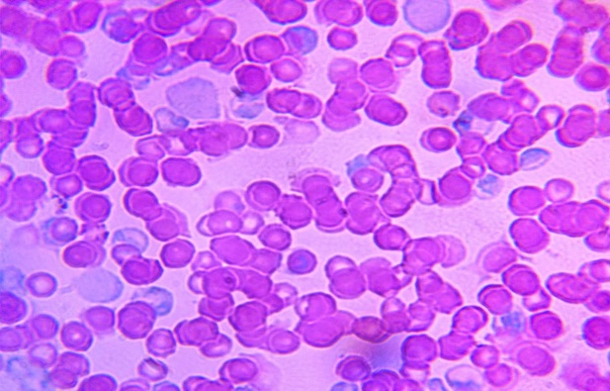
Figure4.1 Blood smear of Plasmodium Bergehi infected cells of mice after first day of infection.
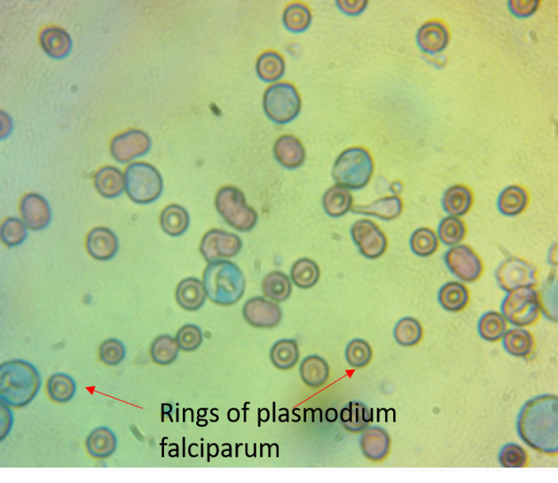
Figure 4.2a
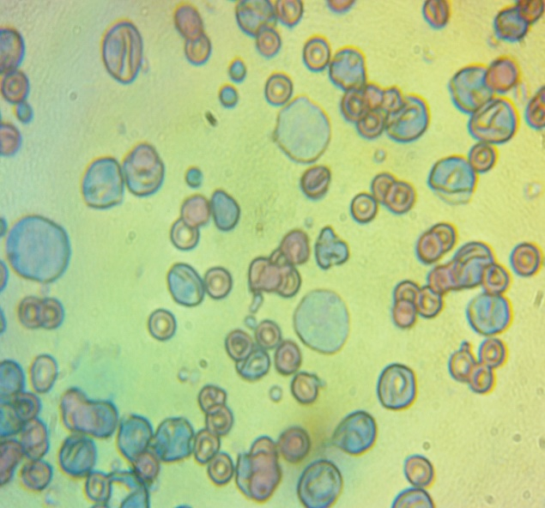
Figure 4.2b
Representative photomicrograph of blood smear of infected mice stained with Giemsa stain.
The parasitaemia level was determined by counting the number of parasitized red blood cells out of the total red blood cell in random fields of microscope. The percentage chemo suppression of parasitaemia for each dose level was calculated by comparing the percentage parasitaemia of the controls (positive and negative control) with those of treated mice using the modified Peters and Robinson formula.
% Parasitaemia = $\frac{Parasitizedbloodcells}{Total red bloodcells }X100$
% Chemo suppression = $\frac{\left(A-B\right)}{A}X100$
Where “A” is the average parasitaemia for the negative control group and “B” is the average parasitaemia for the test compounds.

Figure 4.3 Percentage parasitaemia level in mice infected Plasmodium Bergehi

The results indicate that both Chloroquine and the test compound (AHI) are effective at reducing parasitaemia levels in mice infected with Plasmodium berghei. The highest dose of AHI (25 mg/kg) was found to be the most effective at reducing parasitaemia levels, as it showed a significant reduction compared to both the negative control and the positive control (Chloroquine) groups. These findings suggest that AHI has potential as an alternative or complementary treatment for malaria. However, further studies are needed to determine the safety and efficacy of AHI in humans.

Figure 4.4 Percentage chemo suppression of Plasmodium berghei in mice treated with test compound at different doses

The graph shows the percent chemo-suppression of Plasmodium berghei in mice treated with the test compound at different doses. Data were mean value of chemo-suppression calculated as stated in the method section.
Treatment with the test compound at all doses tested resulted in reduction in parasitaemia levels. The highest dose of the test compound (25 mg/kg) showed the highest level of chemo suppression (82.35%). The present study demonstrates that the test compound has significant chemo-suppressive activity against Plasmodium berghei in mice. The highest dose of DHI tested (25 mg/kg) showed great efficacy. These findings suggest that the compound has potential as an alternative or complementary treatment for malaria. However, further studies are needed to determine the safety and efficacy of the compound in humans, and to explore its mechanism of action.

Figure 4.5 The graph represents the percent parasitaemia and percent chemo-suppression in mice infected with malaria parasites and treated with different drugs

Treatment with the test compound at 5 mg/kg, 10 mg/kg, and 25 mg/kg led to 59.02%, 56.27%, and 82.35% chemo-suppression, respectively. The corresponding percent parasitaemia for each treatment was 0.7%, 0.74%, and 0.29%, respectively (with a scale of times 10 in the graph). These results demonstrate a dose-dependent relationship between the drugs and both parasitaemia and chemo-suppression in mice infected with malaria parasites.

Table 4.1 Chemo suppression Data
Dose | % Parasitemia | Chemo-suppression (%)
Negative Control | 1.70 | 0.00
Chloroquine | 1.4 | 19.3
5 mg/kg | 0.70 | 59.02
10 mg/kg | 0.74 | 56.27
25 mg/kg | 0.29 | 82.35

Mortality was monitored daily and the number of days from the time of inoculation of the parasite up to death was recorded for each mouse in the treatment and control groups throughout the follow-up period. The mean survival time (MST) for each group was calculated using the following formula.
MST= $\frac{Sum of survival time (days) of all mice in a group}{Total number of mice in that group }$

Table 4.2 Animal Survival Rate
 | ANIMAL1 | ANIMAL2 | ANIMAL3 | ANIMAL4 | Mean Survival Time
5mg/Kg | 15 | 22 | 19 | 21 | 19
10mg/Kg | 21 | 24 | 21 | 1 | 17
25mg/Kg | 0 | 30 | 30 | 30 | 23
NC | 16 | 23 | 23 |  | 21
PC | 13 | 30 | 30 |  | 24

Table 4.3 Suppressive Activity of AHI and survival time of P. berghei infected mice in the 4-day suppressive test.
Groups | dose (D0−D3) (0.2 mL/(mouse OD oral)) D0-i.p. inoculation  (1 × 106 P. berghei-infected RBCs) | parasitaemia (%), day 5 | Chemo-suppression  (%), day 5 | Mean survival time/days
G1 | infected control | 1.7 | 0.0
G2 | Chloroquine (10 mg/kg) | 1.4 | 19.3
G3 | AHI (5 mg/kg) | 0.7 | 56.3 | 19.25±1.34
G4 | AHI (10 mg/kg) | 0.7 | 56.6 | 16.75±4.58
G5 | AHI (25 mg/kg) | 0.3 | 82.4 | 25.57.36

4.2 Insilco Studies
Gene Expression Analysis: The RNA-seq dataset used in this study which was gotten from NCBI-Gene Expression Omnibus (GEO) with an ID of GSE198587 was analysed. The gene expression analysis for the selected dataset was analysed using R-Studio. R-Studio v4.2.2 was used for the analysis of this study. The analysed data was used to generate PCA plot, dispersion plot, heat map and volcano plot as seen in the figures below.

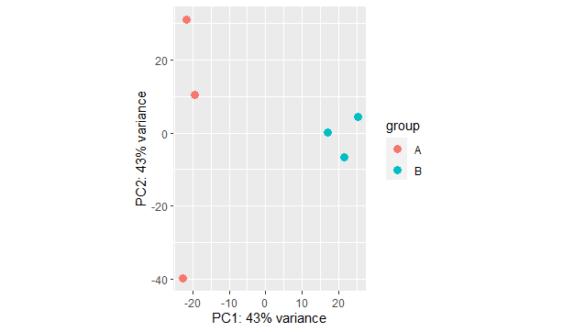
Figure 4.6 PCA (principal component analysis) Plot of analysed dataset identifying clusters of samples similar to each other
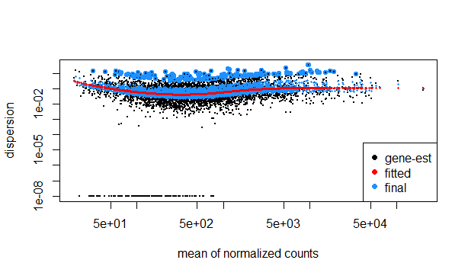
Figure 4.7 Dispersion Plot of the dataset used to measure the variability in gene expression levels, with those highly dispersed plotted towards the top and those with low dispersion towards the bottom

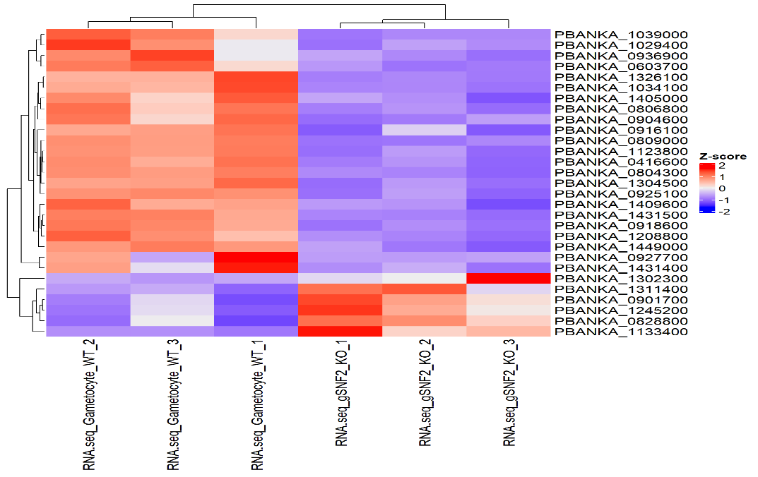
Figure 4.8 : Heat Map showing different expression levels of genes in the data set, with genes in the red region highly expressed and those in the blue region expressed at a low level
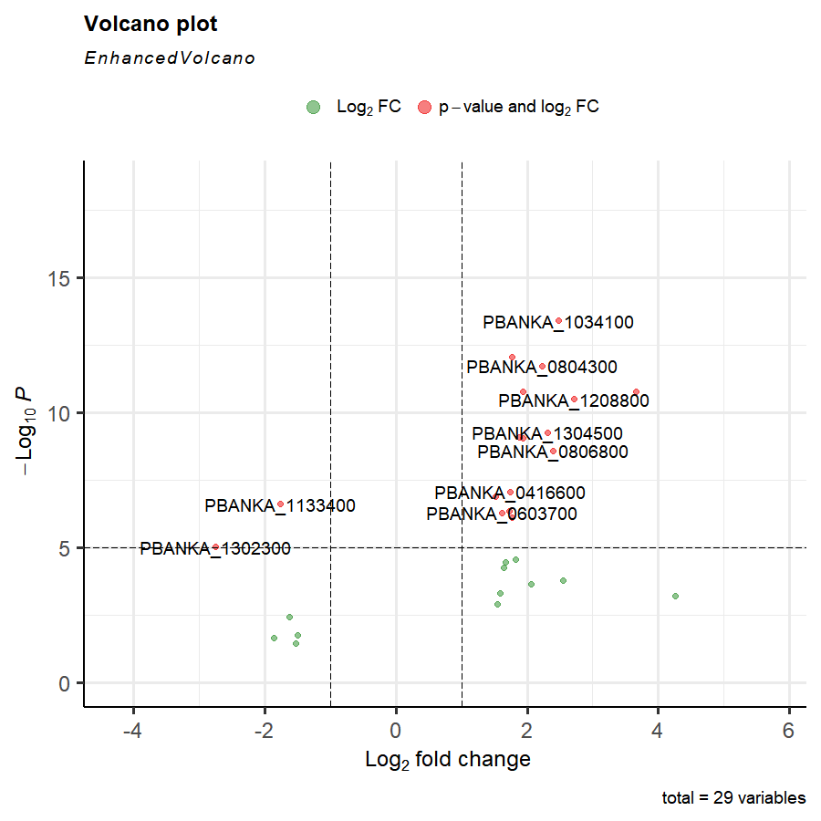
Figure 4.9 Volcano Plot highlighting significantly differentially expressed genes and fold change distance with up-regulated genes scattered upwards in red dots and down-regulated genes scattered downwards with green genes

Molecular Docking: From the volcano plot and heatmap generated, a highly significant/ highly expressed gene was selected as the drug target of the study, in which ‘FANCJ-like Helicase’ (PBANKA_1034100), was selected as the drug target. The molecular docking for this study was done using iGEMDOCK v2.1. The selected protein (FANCJ-like Helicase) and the test ligand ((E)-3-((2,4-dihydroxybenzylidene)amino)-3a,8a-dihydroxyl-2-thioxo-1,3,3a,8a-tetrahydroindeno[1,2-d]imidazol-8(2H)-one) were both uploaded on the iGEMDOCK environment. 5 different poses were generated after docking, and a best pose was indicated by the iGEMDOCK. Binding energies/affinities of the docked protein and ligand were also generated.
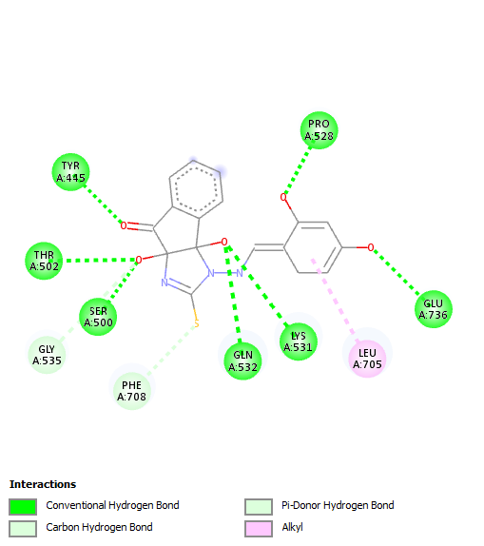
Figure4.10 2D Structure representing interactions between (E)-3-((2,4-dihydroxybenzylidene)amino)-3a,8a-dihydroxyl-2-thioxo-1,3,3a,8a-tetrahydroindeno[1,2-d]imidazol-8(2H)-one and FANCJ-like Helicase

Likewise, the target protein (FANCJ-like Helicase) was docked against Chloroquine which serves as a control due to its known activity against plasmodium infection. Both were uploaded on the iGEMDOCK environment and 5 different poses were also generated after docking, and a best pose was indicated by the iGEMDOCK. Binding energies/affinities of the docked protein and Chloroquine were also generated.

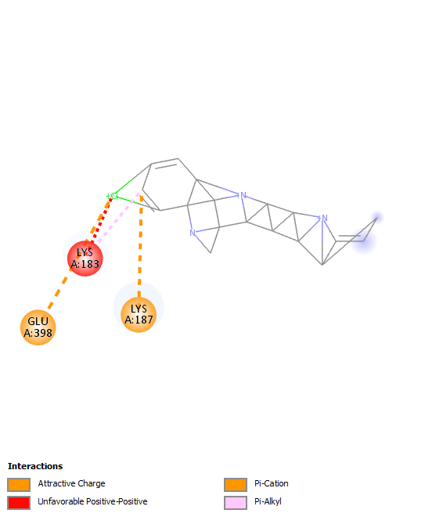
Figure 4.11 2D Structure representing interactions between Chloroquine (control) and FANCJ-like Helicase

Table 4.4 Table showing the binding affinities and interacting amino acids of compounds (test and control) versus the target protein (FANCJ-like Helicase)
Compound | FANCJ-like Helicase protein binding affinity (kcal/mol) | Amino-acid Interaction
Test Ligand:  (E)-3-((2,4-dihydroxybenzylidene)amino)-3a,8a-dihydroxyl-2-thioxo-1,3,3a,8a-tetrahydroindeno[1,2-d]imidazol-8(2H)-one | -112.543 | TYR445, THR502, SER500, GLN532, LYS531, GLU 736, PRO528, GLY535, PHE708, LEU705.
Control:  Chloroquine | -105.475325 | GLU398, LYS187, LYS183.

ADMET STUDY AND DRUG-LIKENESS: In molecular docking of drug discovery, ligands are subjected to drug-likeness to facilitate and standardize the new drug molecule. There are different parameters or rules that the ligands must comply with before it’s accepted as a drug (Otvos & Wade, 2014). The study was used to assess the pharmacokinetic and toxicological properties of potential drug candidates, providing crucial information for optimizing drug efficacy and safety. The ADMET study was conducted on the test ligand to test the integrity of the synthesised drug. The generated results include the physiochemical properties, medicinal chemistry and toxicity, which can be seen in the appendix.

CHAPTER FIVE

DISCUSSION AND CONCLUSION

5.1 DISCUSSION
In a study carried out on the Synthesis of N1-arylidene-N2-quinolyl- and N2- acrydinylhydrazones as potent antimalarial agents active against CQ-resistant P. falciparum strains, a series of novel and highly active antimalarial agents were synthesized. In particular, compounds 4f–g and 5b–c showed remarkable antimalarial activity especially against CQ-resistant Plasmodium faciparum strains and they represent promising lead structures for the development of new antimalarial drugs. Inhibition of the haem detoxification process seems to be the basis of their mechanism of action (Gemma et al., 2006).
The synthesized compound in this experimental study was tested in-vivo against a strain of Chloroquine-sensitive Plasmodium bergehi, NK-65. The in-vivo experiment for this study revealed significant reductions in parasitaemia levels and improved survival rates in mice treated with the test compared to the control group (Chloroquine). These findings suggest the ability of the test compound to successfully fight Plasmodium berghei infections in an animal model of malaria (mice). From the result of the in-vivo study, there was observed to be a decrease in parasite burden in the mice, most especially for mice dosed with 25mg/kg. The survival rates of the test group for the mice treated with 25mg/kg of the test compound showed a survival rate of an average of 23days (for 4 mice) which shows a very great potential when compared to the control group (Chloroquine) in which the mice had an average survival rate of 24days (for 3 mice). These results highlight the importance of translating in vitro antimalarial activity to in vivo efficacy and provide valuable evidence for the development of the test compound as a potential antimalarial drug.
In another previously carried out study, it was noted that inhibition of fatty acid biosynthesis has been proven to be an appropriate target in inhibiting P. falciparum (Perozzo et al., 2002; Surolia & Surolia, 2001), Escherichia coli (Heath et al., 1998). Among different metabolic processes which occur in P. falciparum for its survival, cell wall biosynthesis remains one of the most important processes. In the study, in-silico studies were carried out on PfENR protein, in which significant hydrogen bond and hydrophobic interactions are observed with the energy minimized structures of ligands and PfENR protein, hence showing that the inhibition of PfENR protein pathway to kill P. falciparum (Makam et al., 2014).
Subsequently, in the in-silico study in this experiment, the analysed dataset which was obtained generated different significant genes, in which these genes serve as a potential drug target for the test compound. A highly significant gene was selected ‘FANCJ-like helicase’, FANCJ-like helicase is a protein that is found in the malaria parasite Plasmodium bergei, it is a member of the FANCJ family of helicases, which are enzymes that unwind DNA. FANCJ-like helicase is involved in the replication of the parasite's genome, DNA, nucleotide and ATP binding and also in the development of the parasite's blood stages. Hence it can serve as a good potential target for antimalarial drugs.
The molecular docking on the test compound and the protein (FANCJ-like helicase) provided insights into the molecular interactions between both within Plasmodium-infected RBCs. The molecular docking elucidated the binding modes and affinity of the test compound within the active sites of the selected proteins which showed a binding energy of -112.543 between the test compound (E)-3-((2,4-dihydroxybenzylidene)amino)-3a,8a-dihydroxyl-2-thioxo-1,3,3a,8a-tetrahydroindeno[1,2-d]imidazol-8(2H)-one and FANCJ-like Helicase. The results also indicate a good number of interactions with FANCJ-like Helicase residues such as TYR445, THR502, SER500, GLN532, LYS531, GLU736, PRO528, GLY535, PHE708, LEU705, these results demonstrate strong interactions between the test compound and protein especially when compared to Chloroquine, a known compound for its effect on plasmodium species, which was used as a control during the course of this study. The Chloroquine docked against the protein (FANCJ-like Helicase) had a binding affinity of -105.475 and also had less amino acid interactions when compared the test compound (E)-3-((2,4-dihydroxybenzylidene)amino)-3a,8a-dihydroxyl-2-thioxo-1,3,3a,8a-tetrahydroindeno[1,2-d]imidazol-8(2H)-one. Its interactions include; GLU398, LYS187, LYS183.
This suggests that the test compound may interfere with crucial cellular processes such as DNA, ATP, and nucleotide binding, thereby potentially leading to the inhibition of parasite growth and proliferation. It also indicates that the test compound has a higher binding affinity when compared to the known Chloroquine compound and hence has a higher possibility of binding the target protein (FANCJ-like Helicase) and exert its pharmacological effect.
The integration of in-vivo and in-silico approaches in this study strengthens our understanding of the effects of the test compound on Plasmodium berghei-infected RBCs. By combining these approaches, we obtain a more comprehensive assessment of the antimalarial activity of the test compound and facilitate the rational design and optimization of future drug candidates in humans, as the ADMET studies conducted on the test compound revealed its conformation to the Lipinski rule, GSK rule Pfizer rule, golden triangle, amongst others. As conformation to these rules have been established to be a basic requirement for a synthesised ligand to follow before being accepted as a drug

5.2 CONCLUSION
Malaria continues to be a major global health concern, with the need for effective antimalarial drugs remaining a high priority. Arylidene hydrazinyl indenoimidazoles (AHIs) have emerged as potential candidates due to their demonstrated antimalarial activity in vitro.
In conclusion, our comprehensive investigation combining in-vivo and in-silico studies sheds light on the potential of arylidene hydrazinyl indenoimidazoles (AHIs) as effective antimalarial agents against Plasmodium berghei-infected red blood cells (RBCs). These findings highlight the therapeutic potential of AHIs in combating Plasmodium berghei infections in an animal model of malaria and the potential of the protein FANCJ-like Helicae as a drug target. Overall, this study contributes to the field of malaria research by identifying differentially expressed genes, predicting potential inhibitory effects of AHI’s, and providing a foundation for future studies.
While these findings are promising, several important considerations should be noted. Firstly, the in-vivo experiments were conducted in a mouse model of Plasmodium berghei infection, and further studies are still needed to evaluate the efficacy and safety of AHIs in other Plasmodium species and in humans. Additionally, the in-silico study provides insights into the molecular interactions but are limited to a simulation time scale. Further experimental validation is crucial to confirm the observed effects and understand the precise mechanisms of action of the test compound.

REFERENCES
Achan, J., Talisuna, A. O., Erhart, A., Yeka, A., Tibenderana, J. K., Baliraine, F. N., Rosenthal, P. J., & D’Alessandro, U. (2011). Quinine, an old anti-malarial drug in a modern world: Role in the treatment of malaria. Malaria Journal, 10, 144. https://doi.org/10.1186/1475-2875-10-144
Achan, J., Tibenderana, J. K., Kyabayinze, D., Wabwire Mangen, F., Kamya, M. R., Dorsey, G., D’Alessandro, U., Rosenthal, P. J., & Talisuna, A. O. (2009). Effectiveness of quinine versus artemether-lumefantrine for treating uncomplicated falciparum malaria in Ugandan children: Randomised trial. The BMJ, 339, b2763. https://doi.org/10.1136/bmj.b2763
Acharya, P., Garg, M., Kumar, P., Munjal, A., & Raja, K. D. (2017). Host–Parasite Interactions in Human Malaria: Clinical Implications of Basic Research. Frontiers in Microbiology, 8, 889. https://doi.org/10.3389/fmicb.2017.00889
Aguiar, A. C. C., Rocha, E. M. da, Souza, N. B. de, França, T. C., & Krettli, A. U. (2012). New approaches in antimalarial drug discovery and development: A review. Memórias Do Instituto Oswaldo Cruz, 107, 831–845. https://doi.org/10.1590/S0074-02762012000700001
Akinosoglou, K.-A., & Pasvol, G. (2011). The management of malaria in adults. Clinical Medicine, 11(5), 497–501. https://doi.org/10.7861/clinmedicine.11-5-497
Ashley, E. A., & Phyo, A. P. (2018). Drugs in Development for Malaria. Drugs, 78(9), 861–879. https://doi.org/10.1007/s40265-018-0911-9
Ashley, E. A., Recht, J., & White, N. J. (2014). Primaquine: The risks and the benefits. Malaria Journal, 13(1), 418. https://doi.org/10.1186/1475-2875-13-418
Baptista, F. G., Pamplona, A., Pena, A. C., Mota, M. M., Pied, S., & Vigário, A. M. (2010). Accumulation of Plasmodium berghei-Infected Red Blood Cells in the Brain Is Crucial for the Development of Cerebral Malaria in Mice. Infection and Immunity, 78(9), 4033–4039. https://doi.org/10.1128/IAI.00079-10
Burgert, L., Zaloumis, S., Dini, S., Marquart, L., Cao, P., Cherkaoui, M., Gobeau, N., McCarthy, J., Simpson, J. A., Möhrle, J. J., & Penny, M. A. (2021). Parasite-Host Dynamics throughout Antimalarial Drug Development Stages Complicate the Translation of Parasite Clearance. Antimicrobial Agents and Chemotherapy, 65(4). https://doi.org/10.1128/AAC.01539-20
Chu, X., Bleasby, K., & Evers, R. (2013). Species differences in drug transporters and implications for translating preclinical findings to humans. Expert Opinion on Drug Metabolism & Toxicology, 9(3), 237–252. https://doi.org/10.1517/17425255.2013.741589
Cobbold, S. A., V Tutor, M., Frasse, P., McHugh, E., Karnthaler, M., Creek, D. J., Odom John, A., Tilley, L., Ralph, S. A., & McConville, M. J. (2021). Non‐canonical metabolic pathways in the malaria parasite detected by isotope‐tracing metabolomics. Molecular Systems Biology, 17(4), e10023. https://doi.org/10.15252/msb.202010023
Corbett, A. H. (2018). Post-transcriptional Regulation of Gene Expression and Human Disease. Current Opinion in Cell Biology, 52, 96–104. https://doi.org/10.1016/j.ceb.2018.02.011
Coulibaly, W. K., Paquin, L., Bénie, A., Bekro, Y.-A., Durieu, E., Meijer, L., & Bazureau, J. P. (2012). Synthesis of N,N′-bis(5-arylidene-4-oxo-3,5-dihydro-4H-imidazol-2-yl)diamines bearing various linkers and biological evaluation as potential inhibitors of kinases. European Journal of Medicinal Chemistry, 58, 581–590. https://doi.org/10.1016/j.ejmech.2012.08.044
Cui, L., Mharakurwa, S., Ndiaye, D., Rathod, P. K., & Rosenthal, P. J. (2015). Antimalarial Drug Resistance: Literature Review and Activities and Findings of the ICEMR Network. The American Journal of Tropical Medicine and Hygiene, 93(3 Suppl), 57–68. https://doi.org/10.4269/ajtmh.15-0007
De Vivo, M., Masetti, M., Bottegoni, G., & Cavalli, A. (2016). Role of Molecular Dynamics and Related Methods in Drug Discovery. Journal of Medicinal Chemistry, 59(9), 4035–4061. https://doi.org/10.1021/acs.jmedchem.5b01684
DEHGHAN, H., OSHAGHI, M. A., MOSA-KAZEMI, S. H., ABAI, M. R., RAFIE, F., NATEGHPOUR, M., MOHAMMADZADEH, H., FARIVAR, L., & MOHAMMADI BAVANI, M. (2018). Experimental Study on Plasmodium berghei, Anopheles Stephensi, and BALB/c Mouse System: Implications for Malaria Transmission Blocking Assays. Iranian Journal of Parasitology, 13(4), 549–559.
Delves, M., Plouffe, D., Scheurer, C., Meister, S., Wittlin, S., Winzeler, E. A., Sinden, R. E., & Leroy, D. (2012). The Activities of Current Antimalarial Drugs on the Life Cycle Stages of Plasmodium: A Comparative Study with Human and Rodent Parasites. PLOS Medicine, 9(2), e1001169. https://doi.org/10.1371/journal.pmed.1001169
Denayer, T., Stöhr, T., & Van Roy, M. (2014). Animal models in translational medicine: Validation and prediction. New Horizons in Translational Medicine, 2(1), 5–11. https://doi.org/10.1016/j.nhtm.2014.08.001
Ferreira, L. G., Dos Santos, R. N., Oliva, G., & Andricopulo, A. D. (2015). Molecular Docking and Structure-Based Drug Design Strategies. Molecules, 20(7), Article 7. https://doi.org/10.3390/molecules200713384
Forlemu, N., Watkins, P., & Sloop, J. (2016). Molecular Docking of Selective Binding Affinity of Sulfonamide Derivatives as Potential Antimalarial Agents Targeting the Glycolytic Enzymes: GAPDH, Aldolase and TPI. Open Journal of Biophysics, 7(1), Article 1. https://doi.org/10.4236/ojbiphy.2017.71004
Gemma, S., Kukreja, G., Fattorusso, C., Persico, M., Romano, M. P., Altarelli, M., Savini, L., Campiani, G., Fattorusso, E., Basilico, N., Taramelli, D., Yardley, V., & Butini, S. (2006). Synthesis of N1-arylidene-N2-quinolyl- and N2-acrydinylhydrazones as potent antimalarial agents active against CQ-resistant P. falciparum strains. Bioorganic & Medicinal Chemistry Letters, 16(20), 5384–5388. https://doi.org/10.1016/j.bmcl.2006.07.060
Geng, H., Chen, F., Ye, J., & Jiang, F. (2019). Applications of Molecular Dynamics Simulation in Structure Prediction of Peptides and Proteins. Computational and Structural Biotechnology Journal, 17, 1162–1170. https://doi.org/10.1016/j.csbj.2019.07.010
Georgiadou, A., Dunican, C., Soro-Barrio, P., Lee, H. J., Kaforou, M., & Cunnington, A. J. (2022). Comparative transcriptomic analysis reveals translationally relevant processes in mouse models of malaria. ELife, 11, e70763. https://doi.org/10.7554/eLife.70763
Goodman, A. L., Forbes, E. K., Williams, A. R., Douglas, A. D., de Cassan, S. C., Bauza, K., Biswas, S., Dicks, M. D. J., Llewellyn, D., Moore, A. C., Janse, C. J., Franke-Fayard, B. M., Gilbert, S. C., Hill, A. V. S., Pleass, R. J., & Draper, S. J. (2013). The utility of Plasmodium berghei as a rodent model for anti-merozoite malaria vaccine assessment. Scientific Reports, 3, 1706. https://doi.org/10.1038/srep01706
Govindarajan, R., Duraiyan, J., Kaliyappan, K., & Palanisamy, M. (2012). Microarray and its applications. Journal of Pharmacy & Bioallied Sciences, 4(Suppl 2), S310–S312. https://doi.org/10.4103/0975-7406.100283
Halliday, K. E., Witek-McManus, S. S., Opondo, C., Mtali, A., Allen, E., Bauleni, A., Ndau, S., Phondiwa, E., Ali, D., Kachigunda, V., Sande, J. H., Jawati, M., Verney, A., Chimuna, T., Melody, D., Moestue, H., Roschnik, N., Brooker, S. J., & Mathanga, D. P. (2020). Impact of school-based malaria case management on school attendance, health and education outcomes: A cluster randomised trial in southern Malawi. BMJ Global Health, 5(1), e001666. https://doi.org/10.1136/bmjgh-2019-001666
Heath, M., Bowyer, K., Kopans, D., Kegelmeyer, P., Moore, R., Chang, K., & Munishkumaran, S. (1998). Current Status of the Digital Database for Screening Mammography. In N. Karssemeijer, M. Thijssen, J. Hendriks, & L. van Erning (Eds.), Digital Mammography: Nijmegen, 1998 (pp. 457–460). Springer Netherlands. https://doi.org/10.1007/978-94-011-5318-8_75
Hollingsworth, S. A., & Dror, R. O. (2018). Molecular dynamics simulation for all. Neuron, 99(6), 1129–1143. https://doi.org/10.1016/j.neuron.2018.08.011
Hospital, A., Goñi, J. R., Orozco, M., & Gelpí, J. L. (2015). Molecular dynamics simulations: Advances and applications. Advances and Applications in Bioinformatics and Chemistry : AABC, 8, 37–47. https://doi.org/10.2147/AABC.S70333
Huang, B. W., Pearman, E., & Kim, C. C. (2015). Mouse Models of Uncomplicated and Fatal Malaria. Bio-Protocol, 5(13), e1514.
Jacquerioz, F. A., & Croft, A. M. (2009). Drugs for preventing malaria in travellers. Cochrane Database of Systematic Reviews, 4. https://doi.org/10.1002/14651858.CD006491.pub2
Khaligh, N. G., Mihankhah, T., & Johan, M. R. (2019). An alternative, practical, and ecological protocol for synthesis of arylidene analogues of Meldrum’s acid as useful intermediates. Research on Chemical Intermediates, 45(5), 3291–3300. https://doi.org/10.1007/s11164-019-03796-2
Kim, J., Koo, B.-K., & Knoblich, J. A. (2020). Human organoids: Model systems for human biology and medicine. Nature Reviews Molecular Cell Biology, 21(10), Article 10. https://doi.org/10.1038/s41580-020-0259-3
Knobloch, J., Suhendro, D. K., Zieleniecki, J. L., Shapter, J. G., & Köper, I. (2015). Membrane–drug interactions studied using model membrane systems. Saudi Journal of Biological Sciences, 22(6), 714–718. https://doi.org/10.1016/j.sjbs.2015.03.007
Kukurba, K. R., & Montgomery, S. B. (2015). RNA Sequencing and Analysis. Cold Spring Harbor Protocols, 2015(11), 951–969. https://doi.org/10.1101/pdb.top084970
Langhorne, J., Buffet, P., Galinski, M., Good, M., Harty, J., Leroy, D., Mota, M. M., Pasini, E., Renia, L., Riley, E., Stins, M., & Duffy, P. (2011). The relevance of non-human primate and rodent malaria models for humans. Malaria Journal, 10(1), 23. https://doi.org/10.1186/1475-2875-10-23
Lara, Z., & Tariq, S. (2022, August 8). Plasmodium Falciparum Malaria—StatPearls—NCBI Bookshelf. https://www.ncbi.nlm.nih.gov/books/NBK555962/
Larsen, A. H. (2022). Molecular Dynamics Simulations of Curved Lipid Membranes. International Journal of Molecular Sciences, 23(15), 8098. https://doi.org/10.3390/ijms23158098
Leann, T., Judith, S., Nina F, G., Stuart A, R., & David A, F. (2016, June 8). Artemisinin Action and Resistance in Plasmodium falciparum: Trends in Parasitology. https://www.cell.com/trends/parasitology/fulltext/S1471-4922(16)30073-3?_returnURL=https%3A%2F%2Flinkinghub.elsevier.com%2Fretrieve%2Fpii%2FS1471492216300733%3Fshowall%3Dtrue
Lee, H. J., Georgiadou, A., Walther, M., Nwakanma, D., Stewart, L. B., Levin, M., Otto, T. D., Conway, D. J., Coin, L. J., & Cunnington, A. J. (2018). Integrated pathogen load and dual transcriptome analysis of systemic host-pathogen interactions in severe malaria. Science Translational Medicine, 10(447), eaar3619. https://doi.org/10.1126/scitranslmed.aar3619
Lei, Z.-N., Wu, Z.-X., Dong, S., Yang, D.-H., Zhang, L., Ke, Z., Zou, C., & Chen, Z.-S. (2020). Chloroquine and hydroxychloroquine in the treatment of malaria and repurposing in treating COVID-19. Pharmacology & Therapeutics, 216, 107672. https://doi.org/10.1016/j.pharmthera.2020.107672
Lorke, D. (1983). A new approach to practical acute toxicity testing. Archives of Toxicology, 54(4), 275–287. https://doi.org/10.1007/BF01234480
Ludlow, J. T., Wilkerson, R. G., & Nappe, T. M. (2022). Methemoglobinemia. In StatPearls [Internet]. StatPearls Publishing. https://www.ncbi.nlm.nih.gov/books/NBK537317/
Maiga, F. O., Wele, M., Toure, S. M., Keita, M., Tangara, C. O., Refeld, R. R., Thiero, O., Kayentao, K., Diakite, M., Dara, A., Li, J., Toure, M., Sagara, I., Djimdé, A., Mather, F. J., Doumbia, S. O., & Shaffer, J. G. (2021). Artemisinin-based combination therapy for uncomplicated Plasmodium faciparum malaria in Mali: A systematic review and meta-analysis. Malaria Journal, 20(1), 356. https://doi.org/10.1186/s12936-021-03890-0
Makam, P., Thakur, P. K., & Kannan, T. (2014). In vitro and in silico antimalarial activity of 2-(2-hydrazinyl)thiazole derivatives. European Journal of Pharmaceutical Sciences, 52, 138–145. https://doi.org/10.1016/j.ejps.2013.11.001
Marshall, J. M., & Taylor, C. E. (2009). Malaria Control with Transgenic Mosquitoes. PLoS Medicine, 6(2), e1000020. https://doi.org/10.1371/journal.pmed.1000020
Masopust, D., Sivula, C. P., & Jameson, S. C. (2017). Of Mice, Dirty Mice, and Men: Using Mice to Understand Human Immunology. Journal of Immunology (Baltimore, Md. : 1950), 199(2), 383–388. https://doi.org/10.4049/jimmunol.1700453
Meng, X.-Y., Zhang, H.-X., Mezei, M., & Cui, M. (2011). Molecular Docking: A powerful approach for structure-based drug discovery. Current Computer-Aided Drug Design, 7(2), 146–157.
Mengiste, B., Makonnen, E., & Urga, K. (2012). Invivo Antimalarial Activity of Dodonaea Angustifolia Seed Extracts Against Plasmodium berghei in Mice Model. Momona Ethiopian Journal of Science, 4(1), Article 1. https://doi.org/10.4314/mejs.v4i1.74056
Mswahili, M. E., Martin, G. L., Woo, J., Choi, G. J., & Jeong, Y.-S. (2021). Antimalarial Drug Predictions Using Molecular Descriptors and Machine Learning against Plasmodium faciparum. Biomolecules, 11(12), Article 12. https://doi.org/10.3390/biom11121750
Müller, K., Silvie, O., Mollenkopf, H.-J., & Matuschewski, K. (2021). Pleiotropic Roles for the Plasmodium berghei RNA Binding Protein UIS12 in Transmission and Oocyst Maturation. Frontiers in Cellular and Infection Microbiology, 11. https://www.frontiersin.org/articles/10.3389/fcimb.2021.624945
Newton, C. R. J. C., & Krishna, S. (1998). Severe Falciparum Malaria in Children: Current Understanding of Pathophysiology and Supportive Treatment. Pharmacology & Therapeutics, 79(1), 1–53. https://doi.org/10.1016/S0163-7258(98)00008-4
Okombo, J., Kanai, M., Deni, I., & Fidock, D. A. (2021). Genomic and Genetic Approaches to Studying Antimalarial Drug Resistance and Plasmodium Biology. Trends in Parasitology, 37(6), 476. https://doi.org/10.1016/j.pt.2021.02.007
Osei‐Akoto, A., Orton, L. C., & Owusu‐Ofori, S. (2005). Atovaquone‐proguanil for treating uncomplicated malaria. The Cochrane Database of Systematic Reviews, 2005(4). https://doi.org/10.1002/14651858.CD004529.pub2
Otto, T. D., Böhme, U., Jackson, A. P., Hunt, M., Franke-Fayard, B., Hoeijmakers, W. A. M., Religa, A. A., Robertson, L., Sanders, M., Ogun, S. A., Cunningham, D., Erhart, A., Billker, O., Khan, S. M., Stunnenberg, H. G., Langhorne, J., Holder, A. A., Waters, A. P., Newbold, C. I., … Janse, C. J. (2014). A comprehensive evaluation of rodent malaria parasite genomes and gene expression. BMC Biology, 12, 86. https://doi.org/10.1186/s12915-014-0086-0
Otvos, L., & Wade, J. D. (2014). Current challenges in peptide-based drug discovery. Frontiers in Chemistry, 2, 62. https://doi.org/10.3389/fchem.2014.00062
Pagadala, N. S., Syed, K., & Tuszynski, J. (2017). Software for molecular docking: A review. Biophysical Reviews, 9(2), 91–102. https://doi.org/10.1007/s12551-016-0247-1
Perozzo, R., Kuo, M., Sidhu, A. bir S., Valiyaveettil, J. T., Bittman, R., Jacobs, W. R., Fidock, D. A., & Sacchettini, J. C. (2002). Structural Elucidation of the Specificity of the Antibacterial Agent Triclosan for Malarial Enoyl Acyl Carrier Protein Reductase ∗. Journal of Biological Chemistry, 277(15), 13106–13114. https://doi.org/10.1074/jbc.M112000200
Physiology of Mus musculus—Immune system. (n.d.). Retrieved 26 May 2023, from https://www.ufrgs.br/imunovet/molecular_immunology/immunitymusmusculus.html
Pinzi, L., & Rastelli, G. (2019). Molecular Docking: Shifting Paradigms in Drug Discovery. International Journal of Molecular Sciences, 20(18), 4331. https://doi.org/10.3390/ijms20184331
Plewes, K., Leopold, S. J., Kingston, H. W. F., & Dondorp, A. M. (2019). Malaria: What’s New in the Management of Malaria? Infectious Disease Clinics of North America, 33(1), 39–60. https://doi.org/10.1016/j.idc.2018.10.002
Prevention, C.-C. for D. C. and. (2021, December 16). CDC - Malaria—Malaria Worldwide—Impact of Malaria. https://www.cdc.gov/malaria/malaria_worldwide/impact.html
Rodriguez-Esteban, R., & Jiang, X. (2017). Differential gene expression in disease: A comparison between high-throughput studies and the literature. BMC Medical Genomics, 10(1), 59. https://doi.org/10.1186/s12920-017-0293-y
Róg, T., Girych, M., & Bunker, A. (2021). Mechanistic Understanding from Molecular Dynamics in Pharmaceutical Research 2: Lipid Membrane in Drug Design. Pharmaceuticals, 14(10), Article 10. https://doi.org/10.3390/ph14101062
Roux, A. T., Maharaj, L., Oyegoke, O., Akoniyon, O. P., Adeleke, M. A., Maharaj, R., & Okpeku, M. (2021). Chloroquine and Sulfadoxine–Pyrimethamine Resistance in Sub-Saharan Africa—A Review. Frontiers in Genetics, 12. https://www.frontiersin.org/articles/10.3389/fgene.2021.668574
Sá, J. M., Chong, J. L., & Wellems, T. E. (2011). Malaria drug resistance: New observations and developments. Essays in Biochemistry, 51, 137–160. https://doi.org/10.1042/bse0510137
Shretta, R., Liu, J., Cotter, C., Cohen, J., Dolenz, C., Makomva, K., Newby, G., Ménard, D., Phillips, A., Tatarsky, A., Gosling, R., & Feachem, R. (2017). Malaria Elimination and Eradication. In Major Infectious Diseases. 3rd edition. The International Bank for Reconstruction and Development / The World Bank. https://doi.org/10.1596/978-1-4648-0524-0_ch12
Silva, H. B. da, Fonseca, R., Cassado, A. dos A., Salles, É. M. de, Menezes, M. N. de, Langhorne, J., Perez, K. R., Cuccovia, I. M., Ryffel, B., Barreto, V. M., Marinho, C. R. F., Boscardin, S. B., Álvarez, J. M., D’Império-Lima, M. R., & Tadokoro, C. E. (2015). In Vivo Approaches Reveal a Key Role for DCs in CD4+ T Cell Activation and Parasite Clearance during the Acute Phase of Experimental Blood-Stage Malaria. PLOS Pathogens, 11(2), e1004598. https://doi.org/10.1371/journal.ppat.1004598
Smith, M., & Flodman, P. L. (2018). Expanded Insights Into Mechanisms of Gene Expression and Disease Related Disruptions. Frontiers in Molecular Biosciences, 5. https://doi.org/10.3389/fmolb.2018.00101
Snow, R. W., & Omumbo, J. A. (2006). Malaria. In Disease and Mortality in Sub-Saharan Africa. 2nd edition. The International Bank for Reconstruction and Development / The World Bank. https://www.ncbi.nlm.nih.gov/books/NBK2286/
Šponer, J., Banáš, P., Jurečka, P., Zgarbová, M., Kührová, P., Havrila, M., Krepl, M., Stadlbauer, P., & Otyepka, M. (2014). Molecular Dynamics Simulations of Nucleic Acids. From Tetranucleotides to the Ribosome. The Journal of Physical Chemistry Letters, 5(10), 1771–1782. https://doi.org/10.1021/jz500557y
Staines, H., & Krishna, S. (2012). Treatment and prevention of Malaria: Antimalarial drug chemistry, action and use. In Treatment and Prevention of Malaria: Antimalarial Drug Chemistry, Action and Use (p. 315). https://doi.org/10.1007/978-3-0346-0480-2
Su, X., Lane, K. D., Xia, L., Sá, J. M., & Wellems, T. E. (2019). Plasmodium Genomics and Genetics: New Insights into Malaria Pathogenesis, Drug Resistance, Epidemiology, and Evolution. Clinical Microbiology Reviews, 32(4), e00019-19. https://doi.org/10.1128/CMR.00019-19
Surolia, N., & Surolia, A. (2001). Triclosan offers protection against blood stages of malaria by inhibiting enoyl-ACP reductase of Plasmodium faciparum. Nature Medicine, 7(2), 167–173. https://doi.org/10.1038/84612
Talapko, J., Škrlec, I., Alebić, T., Jukić, M., & Včev, A. (2019). Malaria: The Past and the Present. Microorganisms, 7(6), 179. https://doi.org/10.3390/microorganisms7060179
Tan, K. R., Magill, A. J., Parise, M. E., & Arguin, P. M. (2011). Doxycycline for Malaria Chemoprophylaxis and Treatment: Report from the CDC Expert Meeting on Malaria Chemoprophylaxis. The American Journal of Tropical Medicine and Hygiene, 84(4), 517–531. https://doi.org/10.4269/ajtmh.2011.10-0285
Tran, T. M., & Crompton, P. D. (2020). Decoding the complexities of human malaria through systems immunology. Immunological Reviews, 293(1), 144–162. https://doi.org/10.1111/imr.12817
Tse, E. G., Korsik, M., & Todd, M. H. (2019). The past, present and future of anti-malarial medicines. Malaria Journal, 18(1), 93. https://doi.org/10.1186/s12936-019-2724-z
Venugopal, K., Hentzschel, F., Valkiūnas, G., & Marti, M. (2020). Plasmodium asexual growth and sexual development in the haematopoietic niche of the host. Nature Reviews Microbiology, 18(3), Article 3. https://doi.org/10.1038/s41579-019-0306-2
Vishwakarma, Dr. N., Patel, S., Prabhumay, Mr. N., Kumar, R., & DVN, S. (2010). Molecular Docking Studies of Antimalarial Drugs for Malaria. Journal of Computer Science & Systems Biology, 03. https://doi.org/10.4172/jcsb.1000059
White, N. J. (2004). Antimalarial drug resistance. Journal of Clinical Investigation, 113(8), 1084–1092. https://doi.org/10.1172/JCI200421682
World malaria report 2020. (n.d.). Retrieved 1 February 2023, from https://www.who.int/publications-detail-redirect/9789240015791
Ya’u Ibrahim, Z., Uzairu, A., Shallangwa, G., & Abechi, S. (2020). Molecular docking studies, drug-likeness and in-silico ADMET prediction of some novel β-Amino alcohol grafted 1,4,5-trisubstituted 1,2,3-triazoles derivatives as elevators of p53 protein levels. Scientific African, 10, e00570. https://doi.org/10.1016/j.sciaf.2020.e00570

APPENDICES

APPENDIX I: ADMET STUDY RESULTS


O=C1c2ccccc2[C@]2(O)N(N=Cc3ccc(O)cc3O)C(=S)N[C@]12O

- Physicochemical Property

Property | Value | Comment
Molecular Weight | 371.06 | Contain hydrogen atoms. Optimal:100~600
Volume | 340.085 | Van der Waals volume
Density | 1.091 | Density = MW / Volume
nHA | 8 | Number of hydrogen bond acceptors. Optimal:0~12
nHD | 5 | Number of hydrogen bond donors. Optimal:0~7
nRot | 2 | Number of rotatable bonds. Optimal:0~11
nRing | 4 | Number of rings. Optimal:0~6
MaxRing | 12 | Number of atoms in the biggest ring. Optimal:0~18
nHet | 9 | Number of heteroatoms. Optimal:1~15
fChar | 0 | Formal charge. Optimal:-4 ~4
nRig | 23 | Number of rigid bonds. Optimal:0~30
Flexibility | 0.087 | Flexibility = nRot /nRig
Stereo Centers | 2 | Optimal: ≤ 2
TPSA | 125.62 | Topological Polar Surface Area. Optimal:0~140
logS | -2.921 | Log of the aqueous solubility. Optimal: -4~0.5 log mol/L
logP | 1.658 | Log of the octanol/water partition coefficient. Optimal: 0~3
logD | 1.298 | logP at physiological pH 7.4. Optimal: 1~3
- Medicinal Chemistry

Property | Value | Decision | Comment
QED | 0.378 | ● | - A measure of drug-likeness based on the concept of desirability;  - Attractive: > 0.67; unattractive: 0.49~0.67; too complex: < 0.34
SAscore | 4.045 | ● | - Synthetic accessibility score is designed to estimate ease of synthesis of drug-like molecules.  - SAscore ≥ 6, difficult to synthesize; SAscore <6, easy to synthesize
Fsp3 | 0.118 | ● | - The number of sp3 hybridized carbons / total carbon count, correlating with melting point and solubility.  - Fsp³ ≥0.42 is considered a suitable value.
MCE-18 | 83.474 | ● | - MCE-18 stands for medicinal chemistry evolution.  - MCE-18≥45 is considered a suitable value.

NPscore | 0.192 | - | - Natural product-likeness score.  - This score is typically in the range from −5 to 5. The higher the score is, the higher the probability is that the molecule is a NP.
Lipinski Rule | Accepted | ● | - MW ≤ 500; logP ≤ 5; Hacc ≤ 10; Hdon ≤ 5  - If two properties are out of range, a poor absorption or permeability is possible, one is acceptable.
Pfizer Rule | Accepted | ● | logP > 3; TPSA < 75  Compounds with a high log P (>3) and low TPSA (<75) are likely to be toxic.
GSK Rule | Accepted | ● | - MW ≤ 400; logP ≤ 4  - Compounds satisfying the GSK rule may have a more favorable ADMET profile
Golden Triangle | Accepted | ● | - 200 ≤ MW ≤ 50; -2 ≤ logD ≤ 5  - Compounds satisfying the Golden Triangle rule may have a more favorable ADMET profile.
PAINS | 2 alerts | - | Pan Assay Interference Compounds, frequent hitters, Alpha-screen artifacts and reactive compound.
ALARM NMR | 3 alerts | - | Thiol reactive compounds.
BMS | 0 alerts | - | Undesirable, reactive compounds.
Chelator Rule | 0 alerts | - | Chelating compounds.

- Absorption

Property | Value | Decision | Comment
Caco-2 Permeability | -6.038 | ● | Optimal: higher than -5.15 Log unit
MDCK  Permeability | 1e-05 | ● | - low permeability: < 2 × 10−6 cm/s  - medium permeability: 2–20 × 10−6 cm/s  - high passive permeability: > 20 × 10−6 cm/s
Pgp-inhibitor | 0.03 | ● | - Category 1: Inhibitor; Category 0: Non-inhibitor;  - The output value is the probability of being Pgp-inhibitor
Pgp-substrate | 0.008 | ● | - Category 1: substrate; Category 0: Non-substrate;  - The output value is the probability of being Pgp-substrate
HIA | 0.114 | ● | - Human Intestinal Absorption  - Category 1: HIA+( HIA < 30%); Category 0: HIA-( HIA < 30%); The output value is the probability of being HIA+
F20% | 0.983 | ● | - 20% Bioavailability  - Category 1: F20%+ (bioavailability < 20%); Category 0: F20%- (bioavailability ≥ 20%); The output  value is the probability of being F20%+

F30% | 0.769 | ● | - 30% Bioavailability  - Category 1: F30%+ (bioavailability < 30%); Category 0: F30%- (bioavailability ≥ 30%); The output  value is the probability of being F30%+

- Distribution

Property | Value | Decision | Comment
PPB | 78.13% | ● | - Plasma Protein Binding  - Optimal: < 90%. Drugs with high protein-bound may have a low therapeutic index.
VD | 0.837 | ● | - Volume Distribution  - Optimal: 0.04-20L/kg
BBB  Penetration | 0.093 | ● | - Blood-Brain Barrier Penetration  - Category 1: BBB+; Category 0: BBB-; The output value is the probability of being BBB+
Fu | 5.734% | ● | - The fraction unbound in plasms  - Low: <5%; Middle: 5~20%; High: > 20%
- Metabolism

Property | Value | Comment
CYP1A2 inhibitor | 0.832 | - Category 1: Inhibitor; Category 0: Non-inhibitor;  - The output value is the probability of being inhibitor.
CYP1A2  substrate | 0.094 | - Category 1: Substrate; Category 0: Non-substrate;  - The output value is the probability of being substrate.
CYP2C19  inhibitor | 0.271 | - Category 1: Inhibitor; Category 0: Non-inhibitor;  - The output value is the probability of being inhibitor.
CYP2C19  substrate | 0.122 | - Category 1: Substrate; Category 0: Non-substrate;  - The output value is the probability of being substrate.
CYP2C9 inhibitor | 0.773 | - Category 1: Inhibitor; Category 0: Non-inhibitor;  - The output value is the probability of being inhibitor.
CYP2C9  substrate | 0.29 | - Category 1: Substrate; Category 0: Non-substrate;  - The output value is the probability of being substrate.
CYP2D6 inhibitor | 0.02 | - Category 1: Inhibitor; Category 0: Non-inhibitor;  - The output value is the probability of being inhibitor.
CYP2D6  substrate | 0.201 | - Category 1: Substrate; Category 0: Non-substrate;  - The output value is the probability of being substrate.
CYP3A4 inhibitor | 0.709 | - Category 1: Inhibitor; Category 0: Non-inhibitor;  - The output value is the probability of being inhibitor.
CYP3A4  substrate | 0.922 | - Category 1: Substrate; Category 0: Non-substrate;  - The output value is the probability of being substrate.

- Excretion

Property | Value | Decision | Comment
CL | 4.493 | ● | - Clearance  - High: >15 mL/min/kg; moderate: 5-15 mL/min/kg; low: <5 mL/min/kg
T1/2 | 0.804 | - | - Category 1: long half-life ; Category 0: short half-life;  - long half-life: >3h; short half-life: <3h  - The output value is the probability of having long half-life.
- Toxicity

Property | Value | Decision | Comment
hERG  Blockers | 0.001 | ● | - Category 1: active; Category 0: inactive;  - The output value is the probability of being active.
H-HT | 0.558 | ● | - Human Hepatotoxicity  - Category 1: H-HT positive(+); Category 0: H-HT negative(-);  - The output value is the probability of being toxic.
DILI | 0.99 | ● | - Drug Induced Liver Injury.  - Category 1: drugs with a high risk of DILI; Category 0: drugs with no risk of DILI. The output value is the probability of being toxic.
AMES  Toxicity | 0.842 | ● | - Category 1: Ames positive(+); Category 0: Ames negative(-);  - The output value is the probability of being toxic.
Rat Oral Acute Toxicity | 0.024 | ● | - Category 0: low-toxicity; Category 1: high-toxicity;  - The output value is the probability of being highly toxic.
FDAMDD | 0.031 | ● | - Maximum Recommended Daily Dose  - Category 1: FDAMDD (+); Category 0: FDAMDD (-)  - The output value is the probability of being positive.
Skin Sensiti zation | 0.48 | ● | - Category 1: Sensitizer; Category 0: Non-sensitizer;  - The output value is the probability of being sensitizer.
Carcinogen city | 0.988 | ● | - Category 1: carcinogens; Category 0: non-carcinogens;  - The output value is the probability of being toxic.
Eye Corrosion | 0.003 | ● | - Category 1: corrosives ; Category 0: noncorrosives  - The output value is the probability of being corrosives.
Eye Irritation | 0.024 | ● | - Category 1: irritants ; Category 0: nonirritants  - The output value is the probability of being irritants.

Respiratory Toxicity | 0.629 | ● | - Category 1: respiratory toxicants; Category 0: respiratory nontoxicants  - The output value is the probability of being toxic.

- Environmental toxicity

Property | Value | Comment
Bioconcentration Factors | 0.412 | - Bioconcentration factors are used for considering secondary poisoning potential and assessing risks to human health via the food chain.  - The unit is −log10[(mg/L)/(1000*MW)]
IGC50 | 2.885 | - Tetrahymena pyriformis 50 percent growth inhibition concentration  - The unit is −log10[(mg/L)/(1000*MW)]
LC50FM | 4.323 | - 96-hour fathead minnow 50 percent lethal concentration  - The unit is −log10[(mg/L)/(1000*MW)]
LC50DM | 3.417 | - 48-hour daphnia magna 50 percent lethal concentration  - The unit is −log10[(mg/L)/(1000*MW)]
- Tox21 pathway

Property | Value | Decision | Comment
NR-AR | 0.004 | ● | - Androgen receptor  - Category 1: actives ; Category 0: inactives;  - The output value is the probability of being active.
NR-AR-LBD | 0.008 | ● | - Androgen receptor ligand-binding domain  - Category 1: actives ; Category 0: inactives;  - The output value is the probability of being active.
NR-AhR | 0.656 | ● | - Aryl hydrocarbon receptor  - Category 1: actives ; Category 0: inactives;  - The output value is the probability of being active.
NR-Aromatase | 0.759 | ● | - Category 1: actives ; Category 0: inactives;  - The output value is the probability of being active.
NR-ER | 0.436 | ● | - Estrogen receptor  - Category 1: actives ; Category 0: inactives;  - The output value is the probability of being active.
NR-ER-LBD | 0.005 | ● | - Estrogen receptor ligand-binding domain  - Category 1: actives ; Category 0: inactives;  - The output value is the probability of being active.
NR-PPAR-  gamma | 0.006 | ● | - Peroxisome proliferator-activated receptor gamma  - Category 1: actives ; Category 0: inactives;  - The output value is the probability of being active.
SR-ARE | 0.899 | ● | - Antioxidant response element  - Category 1: actives ; Category 0: inactives;  - The output value is the probability of being active.
SR-ATAD5 | 0.062 | ● | - ATPase family AAA domain-containing protein 5  - Category 1: actives ; Category 0: inactives;  - The output value is the probability of being active.

SR-HSE | 0.164 | ● | - Heat shock factor response element  - Category 1: actives ; Category 0: inactives;  - The output value is the probability of being active.
SR-MMP | 0.86 | ● | - Mitochondrial membrane potential  - Category 1: actives ; Category 0: inactives;  - The output value is the probability of being active.
SR-p53 | 0.884 | ● | - Category 1: actives ; Category 0: inactives;  - The output value is the probability of being active.

- Toxicophore Rules

Property | Value | Comment
Acute Toxicity Rule | 0 alerts | - 20 substructures  - acute toxicity during oral administration
Genotoxic Carcinogenicity Rule | 0 alerts | - 117 substructures  - carcinogenicity or mutagenicity
NonGenotoxic Carcinogenicity Rule | 1 alerts | - 23 substructures  - carcinogenicity through nongenotoxic mechanisms
Skin Sensitization Rule | 5 alerts | - 155 substructures  - skin irritation
Aquatic Toxicity Rule | 0 alerts | - 99 substructures  - toxicity to liquid(water)
NonBiodegradable Rule | 1 alerts | - 19 substructures  - non-biodegradable
SureChEMBL Rule | 1 alerts | - 164 substructures  - MedChem unfriendly status

